ORBIS NPC AUTHORING STUDIO
TECHNICAL DESIGN

  - In-Game Profile Authoring, Generated Character Assistance, Hytale-Native Appearance Composition, Voice Sample Recording, Server-Authoritative Gear and Inventory, Live Stats, and Safe Persistence
Subsystem of ImmersiveNPCs / Orbis
Codex Implementation Specification
Version 1.0 | 2 September 2026

AUTHORITATIVE PURPOSE. Transform the current NPC Profile into a complete in-game NPC authoring workspace while preserving Orbis and Hytale authority. The studio must let creators define profile canon, appearance, voice samples, equipment, inventory, and live statistics without manual JSON editing, player-avatar export, Audacity, or unsafe parallel state. Generated content remains a proposal until explicitly saved.
AUTHORITATIVE AUTHORING  Draft/commit boundaries, stable NPC identity, revision checks, atomic persistence, and no UI-owned truth. | IN-GAME CREATION STUDIO  Floating Gear/Stats, Profile, and coupled Inventory panels with contextual Profile, Appearance, and Voice editors.
NATIVE DATA, SAFE BRIDGES  Hytale ItemContainers, InventoryUtils, CosmeticRegistry, PlayerSkin, voice interception, and entity stats remain underlying authorities. | ORBIS INTEGRATION  Authored canon, generated proposals, voice assets, skin state, and equipment become structured inputs to the existing Orbis cognition and runtime systems.

For Codex implementation use. The existing repository and installed Hytale build remain authoritative. This specification defines ownership and acceptance contracts, but Codex must reconcile class names, API signatures, and current revision state before implementation.

Contents
1. Implementation Directive
2. Executive Decision and Feasibility
3. Product Definition and User Journeys
4. Scope, Goals, and Non-Goals
5. Architectural Principles and Hard Invariants
6. Existing Orbis/Hytale Ownership and Integration Boundary
7. High-Level Architecture
8. Operating Modes, Trust Levels, and Draft/Commit Semantics
9. Unified Authoring Session and Concurrency
10. Custom UI Shell, Panel Manager, and Navigation
11. Visual Design System and Layout Geometry
12. Workspace Navigation State Machine
13. NPC Gear and Stats Panel
14. Coupled Inventory Panel
15. Server-Authoritative Inventory Transaction Completion
16. Gear and Loadout Transaction Architecture
17. Equipment Compatibility and Ammunition Semantics
18. Live Stats Snapshot and Refresh
19. NPC Profile Summary Panel
20. Profile Editor Domain Model
21. Profile Editor UX, Validation, and Unknown-Field Preservation
22. Profile Generation Service
23. Generated Content Provenance and Canon Promotion
24. Appearance Editor Feasibility and API Boundary
25. Cosmetics Catalog Service
26. Skin Domain Model, Adapter, and Draft
27. Appearance UX, Search, Pagination, and Colors
28. Appearance Preview, Validation, Save, and Rollback
29. Cosmetic Thumbnail Strategy
30. Voice Recorder Feasibility and Capture Authority
31. Voice Capture Lease and Recording State Machine
32. Audio Processing, Waveform, and Playback
33. Voice Save/Delete and Chatterbox Integration
34. Persistence, Revisions, Atomicity, and Migrations
35. Threading, Scheduling, and Performance Budgets
36. Permissions, Security, Privacy, and Threat Model
37. Failure Handling and Recovery
38. Observability and Diagnostics
39. Test Architecture and Connected Validation
40. Bounded Implementation Program
41. Definition of Done
Appendix A. Proposed Component Map
Appendix B. Normative Data Contracts
Appendix C. Normative Wireframes and Asset Inventory
Appendix D. State and Event Matrix
Appendix E. Critical Acceptance Test Matrix
Appendix F. Project and External Sources

READING RULE. This document is normative for ownership, state transitions, failure behavior, persistence, and promotion gates. Figures and mockups communicate visual direction; tables and written invariants take precedence when a visual concept conflicts with an authority rule.

1. Implementation Directive
Implement the NPC Authoring Studio as an additive subsystem over the current ImmersiveNPCs / Orbis repository. It replaces neither Orbis cognition nor Hytale runtime authority. It turns the existing NPC Profile into a complete, server-authoritative authoring workspace for profile canon, appearance, voice samples, inventory, equipment, and live statistics.
Codex must begin by auditing the current repository revision. Names such as NpcProfilePage, CustomInventoryTransactionBridge, NpcInventoryRepository, NativeNpcInventoryController, CharacterPreviewComponent, ContextProfileBuilder, CanonicalSpeechLedger, and OrbisResourceScheduler are architectural references derived from the current project history. Reuse the current owner when it exists, rename only through deliberate refactoring, and do not re-create equivalent services under new names.

1.1 Required project reading
- Orbis Conversational Pipeline Hardening Matrix. Preserve its one-owner-per-boundary discipline, canonical speech ownership, failure containment, and regression requirements. [P1]
- Orbis Epistemic Cognition Technical Design. Preserve the separation between reality, belief, speech, authored canon, and inference. [P2]
- Orbis Direct Voice designs. Reuse established voice capture, floor ownership, resource scheduling, cancellation, and speech safety boundaries. [P3, P4]
- Autonomous Evaluation Harness and Model Distillation design. Use existing evaluation and generated-data provenance rules rather than treating generated authoring content as truth. [P5, P6]
- NPC inventory investigations R095-R119. Preserve the proven server-authoritative Custom UI bridge, native ItemContainer authority, stable identity checks, and documented client synchronization limitations. [P7-P11]

1.2 Implementation discipline
- One authority per concern. The UI may render, collect intent, and hold drafts. It may not become a second profile store, inventory, equipment store, skin format, voice repository, stat calculator, or Orbis truth source.
- Current-build verification. Hytale APIs and client behavior are version-sensitive. Reconcile this design against the exact installed server/client build before coding. Record build identity and any deviation from the cited API surface.
- Bounded stages. Implement adjacent stages in one Codex repository session only when each stage retains a separate automated gate, connected gate, rollback artifact, and explicit stop condition.
- No invisible promotion. Generated biography, appearance drafts, and voice drafts are never authoritative until the creator explicitly saves the owning domain.
- No manual inventory copying. Inventory and gear mutation must remain native ItemContainer/InventoryUtils operations. UI snapshots are derived views, not transferable state.
- No blocking callbacks. Voice, UI, packet, world, and model callbacks have different threading constraints. Expensive work must leave the callback immediately and execute in a bounded worker pipeline.
- Preserve rollback. The current working NPC Profile and native inventory fallback remain available until the complete studio passes all domain-specific gates.
DEPLOYMENT GATE. A visually complete studio is not production-ready. Each domain must pass authoritative-state, stale-session, persistence, restart, connected Hytale, and rollback tests before its controls are advertised as active.

2. Executive Decision and Feasibility
Decision: build a custom server-driven NPC Authoring Studio around Hytale's exposed Custom UI, inventory, cosmetics, voice, and entity-stat APIs. Do not attempt to commandeer the native My Avatar controller or embed the native Page.Bench hierarchy into the Custom UI. The project has already proved that Page.Bench owns reliable native inventory behavior, that Page.Bench exposes no usable Anchor UI target in the inspected client revision, and that the one-page Custom UI requires a server-authoritative transaction bridge and explicit UI reconciliation. [P8-P11]
The architecture is technically feasible because the current server API exposes an interactive Custom UI page with typed data events, inventory section resolution and native moves, inbound player voice interception, custom voice streams, a PlayerSkin protocol model, entity-stat access, and armor-slot metadata. The exact cosmetics registry methods and preview integration must still be verified against the installed build before implementation. [H1-H10]
Domain | Feasibility | Primary authority | Principal uncertainty
Workspace shell | High | InteractiveCustomUIPage and packaged Custom UI assets | Responsive composition across UI scale and resolution
Inventory | Proven foundation | Live Player Storage, live NPC ECS Storage, InventoryUtils | Complete merge/split/swap/quick-move matrix and cursor reconciliation
Gear/loadout | High with staged validation | NPC armor/loadout containers and item metadata | Exact offhand and ammunition compatibility semantics
Profile editor | High | Existing profile repository and schema | Unknown-field preservation and revision conflict UX
Generated profile assistance | High | Existing Orbis model/provider and resource scheduler | Quality, latency, and strict proposal-to-canon separation
Appearance editor | High for custom editor | CosmeticRegistry, PlayerSkin, CosmeticsModule, existing preview | Thumbnail availability and exact server-side registry exposure
Voice recorder | Moderate to high | VoiceModule interception, existing Orbis audio stack, voice asset repository | Reliable private capture/playback and capture-vs-conversation arbitration
Live stats | High | EntityStatMap and current combat/stat owners | Mapping a stable player-facing Defense value without recomputation

2.1 Why a dedicated architecture is justified
The Authoring Studio crosses client presentation, server-authoritative ECS state, filesystem persistence, model generation, audio capture, and long-lived NPC identity. Treating these features as unrelated buttons would create duplicate stores, stale previews, unsafe file writes, and events capable of mutating the wrong NPC. A shared session, revision model, event envelope, domain commit protocol, and connected release matrix are therefore architectural requirements rather than polish.

2.2 Supported outcome
A creator should be able to create or update a sophisticated NPC entirely in game: author and generate profile content, construct a validated appearance from Hytale cosmetics, record Chatterbox reference samples, move and equip items, verify live defensive statistics, save each draft explicitly, restart the server, and then converse with the NPC through Orbis using the resulting profile and voice.

2.3 Explicitly unsupported assumptions
- The native My Avatar page is not assumed to be server-callable or redirectable to a non-player target.
- Native client panel names are not assumed to be Anchor UI keys.
- Custom UI ItemGrid is not assumed to reconcile native drag state automatically.
- A cosmetic asset is not assumed to expose a ready-made thumbnail.
- A displayed stat is not assumed to exist merely because the player HUD contains a similar label.
- A voice interceptor is not assumed to provide decoded PCM or a durable frame object.
- A model-generated biography is not assumed to be true, safe, or canon.

3. Product Definition and User Journeys
The NPC Authoring Studio is the creator-facing product shell for ImmersiveNPCs. The existing NPC Profile becomes the overview workspace, while Profile Editor, NPC Appearance, and Voice Recorder become contextual editors that open within the same Custom UI page. Gear, stats, and both inventories remain visible as the main operational surface unless a contextual editor temporarily covers or docks beside them.
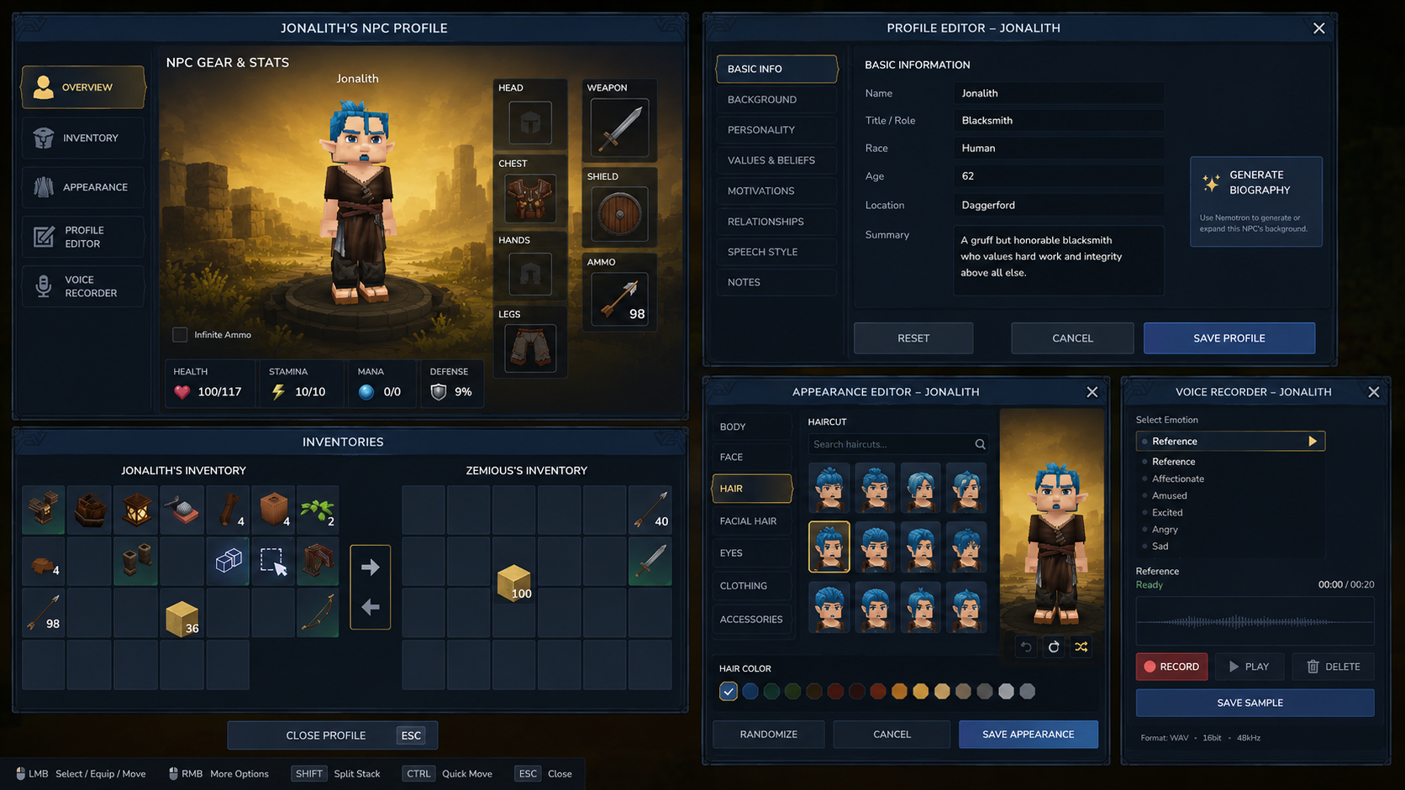
Figure 1. Non-normative concept rendering approved as visual direction. Written geometry, square-slot rules, single-context-editor behavior, and authority contracts in this document take precedence.

3.1 Create-new-NPC journey
- Creator runs /npc create [name].
- The system creates a stable NPC identity and an incomplete authoring session, not a fully valid production profile.
- The workspace opens with Gear/Stats, Profile Summary, and coupled inventories. Missing domains are clearly marked.
- Creator opens Profile Editor, enters identity and character qualities, optionally selects Generate, reviews the proposed patch, edits it, and chooses Save Profile.
- Creator opens NPC Appearance, chooses cosmetics and colors against a draft preview, then chooses Save Appearance.
- Creator opens Voice Recorder, records Reference and any optional emotional samples, privately plays them back, and saves accepted samples.
- Creator assigns equipment and inventory through authoritative item transactions.
- Creator presses the final Enter/Create action only after required domain validity checks pass.
- The NPC becomes spawnable/active under the existing Orbis profile lifecycle.

3.2 Update-existing-NPC journey
- Creator runs /npc update [name].
- The studio resolves the exact profile, stable ID, live entity when present, and current revisions for profile, appearance, voice, inventory, and gear.
- Immediate domains such as inventory and equipment transact against live authoritative containers.
- Draft domains such as profile and appearance remain isolated until their explicit Save actions.
- Closing a dirty contextual editor prompts Save, Discard, or Stay. Closing the entire studio never silently saves drafts.
- The session performs terminal persistence flushes, releases preview/capture leases, invalidates generations, and restores viewer state.

3.3 Player-facing mental model
The creator should perceive one coherent workshop rather than a file browser. The interface should explain what can be edited, show current validity and readiness, and make ownership obvious. It should not expose implementation details such as Nemotron, PlayerSkin class names, InventorySectionId values, or technical rejection enums in normal mode.

4. Scope, Goals, and Non-Goals

4.1 Goals
- Provide complete in-game authoring of an NPC's profile, appearance, voice samples, equipment, inventory, and key live stats.
- Preserve all existing Orbis truth, cognition, memory, action, and speech ownership.
- Reuse Hytale-native data models and transaction APIs wherever current server APIs expose them.
- Keep generated text as an auditable proposal until explicit human save.
- Keep profile, appearance, and voice edits draft-based, revisioned, and atomic.
- Keep inventory and gear immediate, authoritative, replay-protected transactions.
- Eliminate routine dependence on manual JSON editing, player-avatar export, third-party audio recording, and manual file movement.
- Support future world systems such as Kingdoms, roles, schedules, factions, and new Core types without making the authoring UI their authority.

4.2 Non-goals for version 1
- User-draggable floating panels. Panels may look independent but remain layout-managed unless a supported drag contract is proven.
- Collaborative simultaneous editing of the same NPC. Version 1 uses one writer lease per NPC.
- A general-purpose JSON editor.
- A full digital audio workstation, denoiser, or waveform editor.
- Automatic model-generated canon without creator approval.
- Runtime model training or distillation.
- Client-side modifications or replacement of Hytale's native My Avatar page.
- Cross-server profile editing without a future distributed lock and shared persistence authority.
- Arbitrary custom cosmetic creation. The first version selects from the current Hytale cosmetic catalog.
- Inventing defensive or resistance values not present in authoritative Hytale/Orbis state.

4.3 Deferred opportunities
- Template NPCs, clone-from-profile, and archetype presets.
- Nemotron-assisted appearance constraints, such as selecting a weathered elderly blacksmith appearance from semantic criteria.
- Batch voice recording scripts and quality coaching.
- Relationship graph editing and visual faction membership tools.
- Role-specific authoring extensions for guards, hunters, tavern staff, miscreants, kingdoms, schedules, shops, and quests.
- Collaborative editing with domain-specific leases.
- Server-hosted profile marketplace or import/export bundles, subject to asset and voice rights.

5. Architectural Principles and Hard Invariants
Invariant | Normative rule | Failure prevented
UI is not authority | Every display is derived from a domain owner or an explicit draft. UI snapshots never become server truth. | Desync, item duplication, stale profile writes
Stable identity before names | All mutations bind to stable NPC ID plus current entity/storage identity. Display names are never sole keys. | Wrong-NPC mutation and rename drift
One active contextual editor | Profile, Appearance, and Voice editors are mutually exclusive within a session. | Overlapping drafts and ambiguous save actions
Explicit draft promotion | Profile, appearance, generated text, and recorded samples require domain-specific Save. | Silent canon or file mutation
Immediate item transactions | Inventory and gear use native ItemContainer/InventoryUtils transactions and authoritative rereads. | Copy/delete races and item loss
Revision conflict detection | Draft save compares captured base revision/hash against current authority. | Last-write-wins corruption
Generated text is a proposal | Generate cannot directly write profile, memory, beliefs, relationships, world state, or speech ledger. | Hallucinated canon and provenance loss
Voice callback remains non-blocking | Copy bounded opaque frame data, enqueue, and return. Decode and I/O run elsewhere. | Voice stalls and shared executor starvation
Asynchronous results are generation-bound | Late model, preview, catalog, and audio results are rejected after session/editor generation changes. | Stale preview or save
Atomic filesystem commits | Temporary file, validation, atomic replace, rollback copy, and post-commit hash. | Partial JSON/WAV/skin files
Connected evidence outranks static optimism | Client interaction, microphone behavior, preview restoration, and item movement require connected Hytale validation. | False green gates

5.1 Orbis cognition invariants
- Hytale owns reality. The studio may author canon but may not fabricate current world state. [P2]
- Speech is not truth. A generated biography or recorder playback is not conversation evidence. [P2]
- Authored profile data becomes evidence only through the existing profile/canon ingestion path after successful save.
- The same mind drives dialogue and autonomy. The studio changes authoritative inputs, not a separate NPC persona used only by the UI.
- The model is replaceable; the authored NPC state is not. Provider changes must not alter saved identity, profile, appearance, inventory, gear, or voice ownership.

5.2 Editor invariants
- Cancel restores or retains the last authoritative version, never an intermediate generated or preview state.
- Reset means restore the current persisted domain, not erase the domain to defaults.
- Delete requires domain-specific confirmation when it can invalidate an NPC, especially deleting the Reference voice sample.
- Technical diagnostics remain available in traces and developer mode, but player-facing messages are localized and actionable.
- The footer advertises only controls that are actually enabled in the current feature stage.

6. Existing Orbis/Hytale Ownership and Integration Boundary
Codex must map the current code before implementation. The ownership table below describes the intended boundary, not permission to replace current production classes. Where the repository already has an equivalent owner, extend that owner or add a narrow adapter.
Concern | Current/required owner | Authoring Studio responsibility | Forbidden replacement
NPC identity/profile | Existing profile and stable-ID repository | Resolve, draft, validate, atomically patch exposed fields | Name-keyed alternate profile store
Reality/perception | Hytale ECS and Orbis perception | Read only for status/preview where needed | Editor-authored current-world facts
Beliefs/memory/relationships | Epistemic core and persistence | No direct mutation in v1 except through future explicit domain tools | Free-text biography automatically becoming memory
Prompt rendering | Existing ContextProfileBuilder/provider path | Dedicated authoring-generation contract only | Second conversation prompt builder
Delivered speech | CanonicalSpeechLedger and voice delivery | Recorder playback kept private and excluded | Treating playback as canonical NPC speech
Model scheduling | Existing Orbis resource scheduler/provider | Low-priority cancellable Generate requests | Independent unmanaged model process
NPC storage | Live NPC InventoryComponent.Storage + NpcInventoryRepository | Display, validate intent, call native transactions, refresh | Temporary production mirror
Armor/loadout | Existing NPC equipment/loadout authority | Typed transaction endpoints and preview refresh | UI-only equipped state
Appearance | Existing skin JSON + Hytale PlayerSkin/cosmetics path | Draft, validate, preview, atomic save | New proprietary appearance schema
Voice samples | Existing voice profile/sample repository and Chatterbox cache | Capture, validate, atomic save/delete, rescan | Parallel sample naming/cache system
Live stats | Hytale EntityStatMap/combat systems | Build immutable snapshot for display | Local arithmetic approximation

6.1 Inventory research already settled
The project has established that section IDs and native containers are structurally correct, that Page.Bench provides reliable native transaction ownership, that Custom UI ItemGrid can expose trustworthy source and destination intent, and that explicit server-authoritative bridging is required to reconcile the one-page Custom UI. R118 and R119 therefore form the production baseline for future inventory and gear work. [P7-P11]
- Player Storage uses the current built-in storage section ID.
- NPC storage is the exact live ECS Storage container, not a copied SimpleItemContainer.
- Client-supplied item quantity is diagnostic only; the server rereads the source stack.
- The sole ordinary mutation path is InventoryUtils or the relevant native container transaction API.
- Both source and destination are reread after mutation and complete UI slot arrays are refreshed from authority.
- Stable profile, entity, storage-object, session, page, and window identities are validated before mutation.
- Raw enum messages such as AUTHORITATIVE_SOURCE_EMPTY are not suitable for the production UI.

6.2 Preview lifecycle already settled
The studio must preserve the validated NPC preview sequence and viewer restoration contract. Opening a contextual editor may change the draft preview, but it must not mutate the logged-in player's authoritative skin or equipment. Closing, cancellation, page replacement, and reconnect must reject late preview updates and restore the viewer exactly.

6.3 Voice ownership already settled
The recorder is not a new conversational channel. It must lease the existing microphone capture authority, prevent recorded speech from reaching Moonshine and the NPC conversation pipeline, and perform all expensive decode/write work outside the voice callback. The Direct Voice architecture remains authoritative for ordinary conversation. [P3, P4]

7. High-Level Architecture
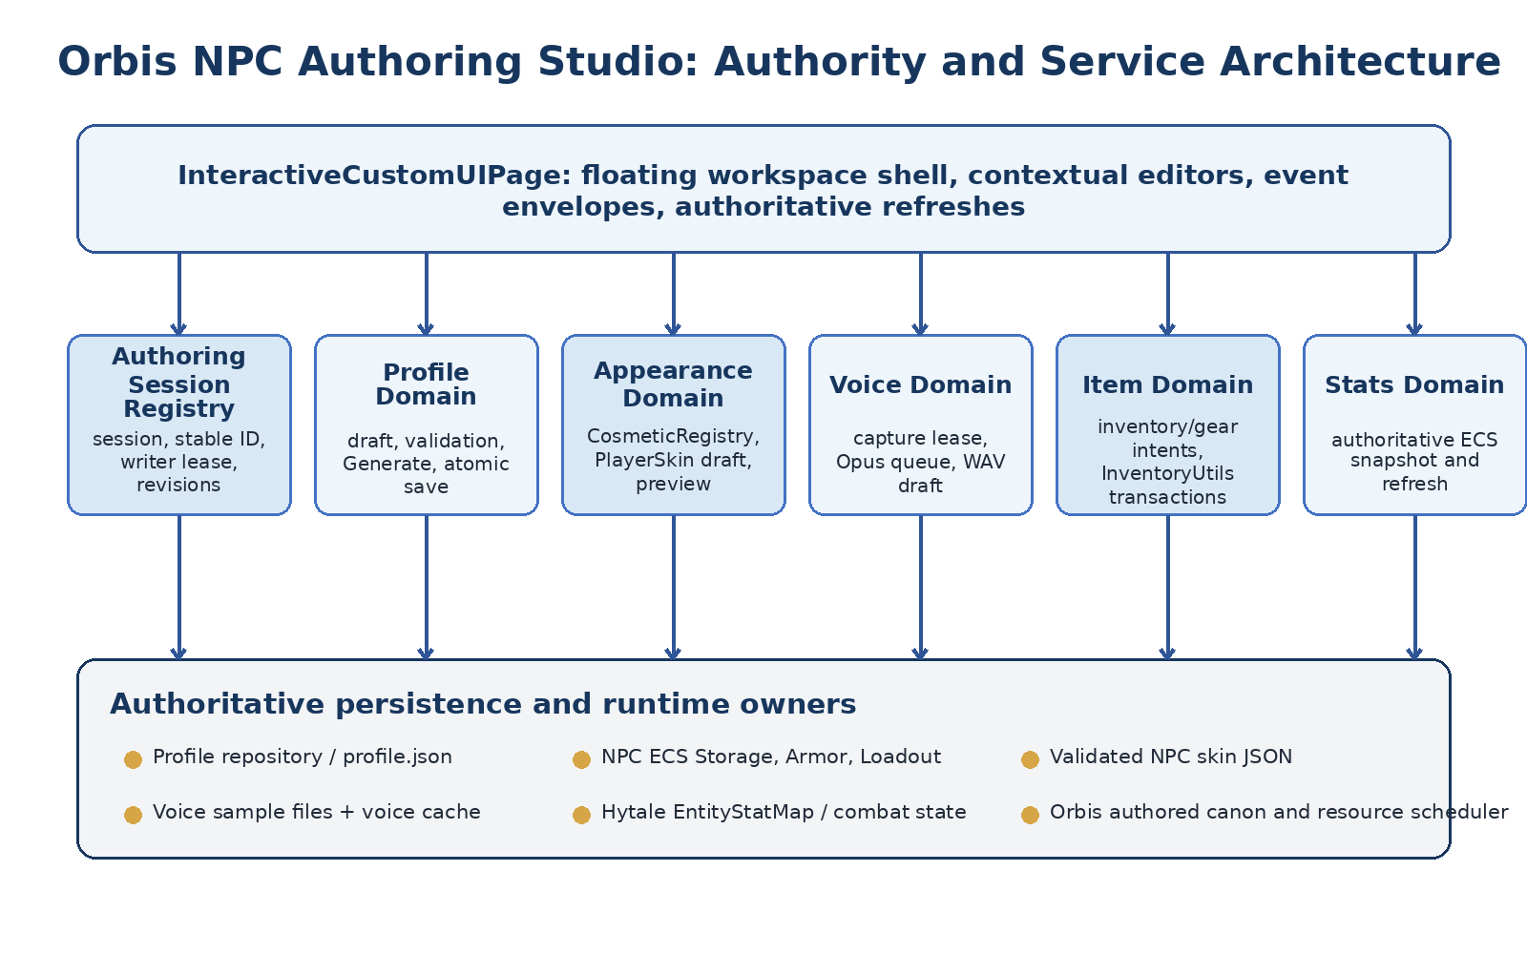
Figure 2. High-level Authoring Studio architecture. The page coordinates domain services; authoritative state remains in existing repositories, ECS components, and Orbis services.

7.1 Layer model
Layer | Responsibilities | May mutate
Presentation | Floating panels, grids, fields, buttons, tooltips, status, draft preview, waveform | No authoritative domain directly
Session/controller | Session IDs, editor selection, writer lease, page generation, dirty state, event decoding | Session-local state only
Draft services | Profile draft, appearance draft, voice recording draft, generated proposal | Draft state only
Domain services | Validation, catalog lookup, inventory/gear policies, stat snapshots, audio finalization | Only through owning repository/API
Authority adapters | Profile repository, NpcInventoryRepository, CosmeticsModule/PlayerSkin adapter, voice asset repository, EntityStatMap | Their own domain
Orbis integration | Authoring generation, canon ingestion, cache invalidation, resource scheduling, evaluation hooks | Only through existing Orbis owners

7.2 Proposed top-level components
- NpcAuthoringStudioPage. InteractiveCustomUIPage shell and central event dispatcher.
- NpcAuthoringSessionRegistry. One active workspace per player and one writer lease per NPC.
- NpcAuthoringPanelManager. Base-panel visibility, contextual-editor selection, responsive placement, and scrim.
- NpcProfileDraftService. Schema-preserving draft, validation, revision conflict detection, and atomic save.
- NpcProfileGenerationService. Provider-neutral, asynchronous, structured proposal generation.
- NpcAppearanceCatalogService. Cached Hytale cosmetics catalog, categories, search, pagination, colors, and capabilities.
- NpcSkinCodecAdapter. Explicit conversion among stored skin JSON, server cosmetics model, and protocol PlayerSkin.
- NpcVoiceRecordingService. Capture lease, bounded Opus queue, worker processing, private playback, and atomic sample save.
- AuthoritativeItemMoveBridge. Generalized storage, gear, split, merge/swap, and quick-move policies over native transactions.
- NpcStatsSnapshotService. World-thread snapshot of authoritative live statistics.
- NpcAuthoringAuditLog. Append-only operation records without raw voice data or model hidden reasoning.

7.3 Component communication rule
All asynchronous components return immutable results carrying session ID, NPC stable ID, domain revision/hash, page generation, and editor generation. The page discards results that do not match the current session. Services do not retain a live Custom UI page reference after dismissal.

8. Operating Modes, Trust Levels, and Draft/Commit Semantics
The studio must separate authoring availability from production authority. A domain may be visible, read-only, editable as a draft, or immediately transactional. Do not infer mode from which controls happen to be visible.
Mode | Meaning | Permitted behavior | Typical trigger
VIEW_ONLY | Profile can be inspected but not mutated | Render persisted state, preview, validity, and diagnostics | Target NPC not spawned, permission missing, or writer lease held
AUTHORING_READY | Base workspace has a valid writer session | Open contextual editors and transact enabled item domains | Profile and identity resolution succeeded
PROFILE_DRAFT | Profile Editor owns a mutable draft | Edit and Generate proposal; no profile persistence until Save Profile | Profile Editor opened
APPEARANCE_DRAFT | Appearance Editor owns a mutable skin draft | Select cosmetics, colors, and preview; no live/persisted skin change until save | NPC Appearance opened
VOICE_DRAFT | Recorder owns a bounded unsaved recording | Record, process, privately play, delete draft, save sample | Voice Recorder opened
COMMITTING | A domain-specific save is in progress | Disable conflicting actions; validate revision and write atomically | Save Profile, Save Appearance, or Save Sample
DEGRADED | A non-critical service is unavailable | Retain manual editing and current persisted state; disable only affected feature | Model unavailable, microphone disabled, catalog refresh failed
CLOSING | Session is invalidating | Reject new events, cancel work, release leases, flush current authorities | Page close, disconnect, NPC delete, plugin shutdown

8.1 Trust levels
Data class | Trust level | How it becomes authoritative
Custom UI event payload | Untrusted intent | Never directly; validate against current session and server state
UI-rendered slot/field value | Presentation snapshot | Never directly; reread owning repository/container
Profile draft | Session-local proposed state | Save Profile after validation and revision check
Generated profile patch | Unverified proposal | Creator reviews/edits, then Save Profile
Appearance draft | Session-local proposed skin | Validate and Save Appearance
Voice recording draft | Unsaved media | Validate and Save Sample
Live ItemContainer state | Authoritative runtime item state | Already authoritative after native transaction
Persisted profile/skin/voice file | Authoritative durable state | Atomic domain save and successful post-write validation
EntityStat snapshot | Read-only authoritative snapshot | Captured from live ECS owner at one instant

8.2 Domain commit model
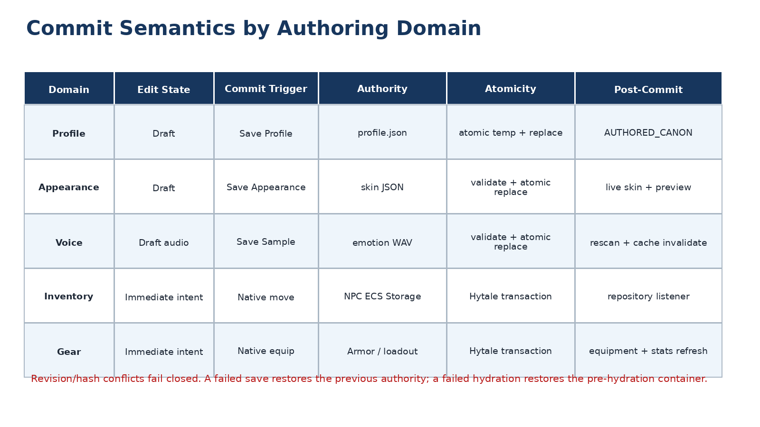
Figure 3. Domain-specific commit semantics. Draft-based domains commit explicitly; inventory and gear transact immediately through native authority.
USER EXPECTATION. Closing Profile Editor, Appearance Editor, or Voice Recorder discards unsaved draft state after confirmation. Closing the overall studio does not reverse inventory or gear transactions that have already committed.

9. Unified Authoring Session and Concurrency
Every workspace open creates one NpcAuthoringSession. The session is the anti-staleness boundary joining the viewer, stable NPC identity, live entity, container/window bindings, editor drafts, preview ownership, voice capture ownership, and domain revisions. It is not a persistence store.
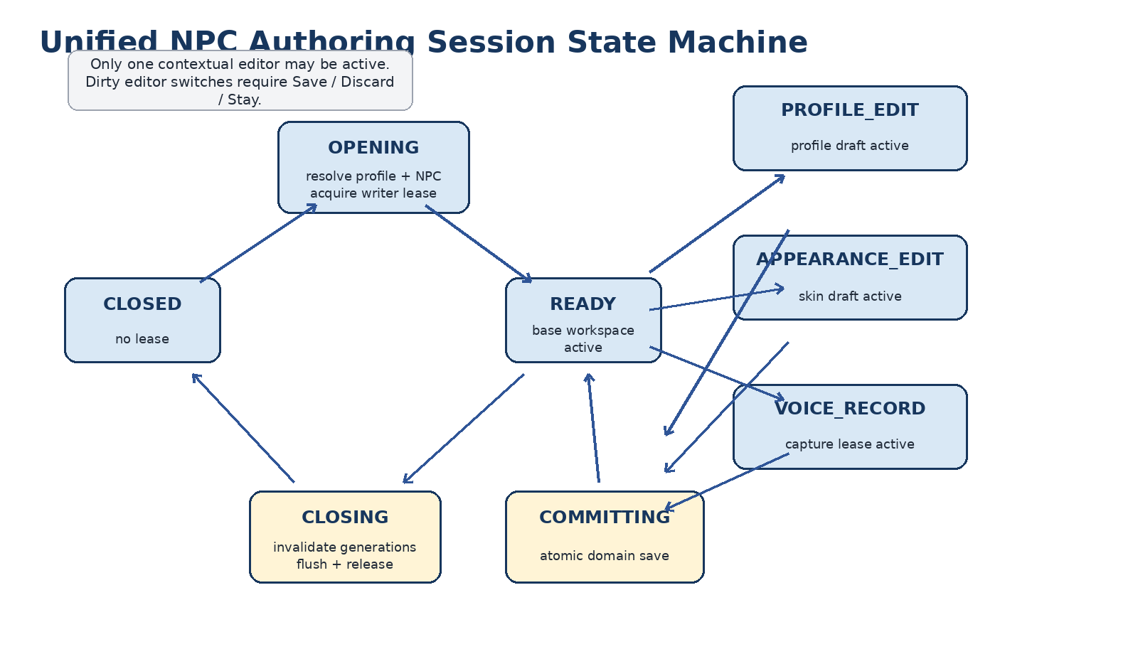
Figure 4. Unified authoring session state machine. Contextual editors are mutually exclusive; saves pass through a committing state; closure invalidates all generations before releasing resources.

9.1 Required session identity
record NpcAuthoringSessionIdentity(
UUID sessionId,
UUID viewerPlayerId,
UUID npcStableId,
UUID npcEntityUuid,
long pageGeneration,
Instant openedAt
) {}
- npcStableId is required even when the NPC is not currently spawned.
- npcEntityUuid and entity Ref are required for live inventory, gear, preview, and stats transactions.
- pageGeneration changes whenever the page instance or authoritative window set changes.
- Each contextual editor has its own editorGeneration and captured base revision/hash.
- A result is accepted only when every applicable identity still matches.

9.2 Session registry
NpcAuthoringSessionRegistry should provide atomic open, lookup, close, and writer-lease operations. The registry must reject a second active workspace for the same player, and it must reject a second writer for the same NPC unless a future read-only collaboration mode is explicitly implemented.
Operation | Precondition | Result | Failure behavior
open(viewer, npc) | Viewer has permission; no active viewer session; no NPC writer lease | Registers session and lease | Readable conflict; no partial page
resolve(event) | Session/page generation matches active page | Returns immutable session view | Reject and refresh or silently ignore stale event
switchEditor(kind) | Current editor clean or creator confirms action | Closes current draft and opens target | Save / Discard / Stay prompt
close(reason) | Any lifecycle path | Marks closing, invalidates generations, releases resources | Idempotent; late events fail closed
heartbeat/validate | Optional for long sessions | Confirms entity/window/storage identity | Degrade live domains or require reopen

9.3 Writer lease
Use one writer lease per NPC across profile, appearance, voice, inventory, and gear in version 1. This is deliberately conservative. Inventory itself may change from gameplay while the studio is open; therefore item operations always reread live state and do not rely on the lease as a substitute for container authority. The lease protects authored files and editor intent from another authoring session, not from legitimate world simulation.

9.4 Revision model
Domain | Captured at open | Conflict check | Conflict response
Profile | Profile revision and canonical JSON hash | Before Save Profile | Preserve draft; show Reload / Copy Draft / Cancel
Appearance | Skin revision and canonical skin hash | Before Save Appearance | Preserve draft; require rebase or discard
Voice sample | Per-emotion sample revision/hash | Before Save/Delete Sample | Do not overwrite; refresh current sample
Inventory | No static revision dependency | Reread source/target immediately before every move | Reject stale move and refresh grids
Gear/loadout | No static revision dependency | Reread source, target, filters, and live equipment immediately | Reject stale move and refresh gear/inventory

9.5 Lifecycle termination
- Page dismissal: invalidate bridge and editor generations before flushing or restoring anything.
- Player disconnect: close session, stop capture/playback, discard drafts, unregister listeners, flush item persistence.
- NPC unload/despawn: retain profile draft if safe, but live inventory/gear/stats become unavailable and events reject until reopen.
- NPC deletion: abort all editors, release writer lease, prevent any late file or item mutation.
- Plugin shutdown/world unload: stop new sessions, close active sessions in bounded time, preserve durable authorities, log incomplete cleanup.

10. Custom UI Shell, Panel Manager, and Navigation
NpcAuthoringStudioPage remains one InteractiveCustomUIPage so profile summary, preview, inventories, and contextual authoring tools share one session and one event envelope. Hytale's InteractiveCustomUIPage supports typed interactive data events; the installed build remains the authority for exact construction and page-lifetime APIs. [H1]

10.1 Base shell
- Gear + Stats floating panel at upper left.
- Profile Summary floating panel at upper right.
- Coupled Inventory floating panel beneath both.
- Contextual editor host capable of rendering one of Profile Editor, NPC Appearance, or Voice Recorder.
- Optional dark scrim while a centered contextual editor is open.
- Slim bottom input legend outside or beneath the coupled inventory panel.
- No giant shared outer frame in the final visual composition.

10.2 Panel manager responsibilities
Responsibility | Required behavior
Composition | Build and update panel documents without replacing authoritative page/window bindings unnecessarily
Visibility | Show one contextual editor, base panels, scrim, status overlays, and confirmation dialogs
Geometry | Select a resolution/UI-scale layout profile and preserve square slots
Dirty navigation | Block editor switch/close until Save, Discard, or Stay is resolved
Event routing | Decode central event envelope and dispatch only allowed action for active editor
Refresh coalescing | Combine related profile, preview, inventory, gear, stats, and voice UI updates
Failure UX | Show localized actionable message and preserve technical reason in trace
Accessibility | Provide readable labels/tooltips and avoid relying on color alone for state

10.3 Panel implementation boundary
Visually floating does not imply independent Custom UI pages. The initial implementation should use separately decorated containers within the same page, placed by NpcAuthoringPanelManager. Do not implement user drag-to-reposition until the current Custom UI event model proves a reliable panel-drag contract that cannot interfere with ItemGrid interaction.

10.4 Contextual editor host
At 1920 x 1080, opening a contextual editor should retain the base workspace behind a restrained scrim and place the editor in the foreground. At 2560 x 1440 and wider, the panel manager may translate the base workspace left and dock the contextual editor to the right. Only one contextual editor is active. The page, inventory windows, and preview ownership should remain stable while editors are switched.

10.5 Confirmation dialogs
- Dirty contextual editor close: Save / Discard / Stay.
- Delete saved voice sample: Delete / Cancel, with stronger warning for Reference.
- Reset draft: Reset to persisted version / Cancel.
- Revision conflict: Reload authority / Copy draft to clipboard or export recovery file / Cancel.
- Discard newly created incomplete NPC: Delete incomplete profile / Keep draft profile / Cancel.

11. Visual Design System and Layout Geometry
The studio should feel native to Hytale without depending on undocumented native client asset paths. Reuse the supported Common UI style library where appropriate, and package project-authored images inside the ImmersiveNPCs asset pack. Hytale's shared Common.ui styles are intended to help Custom UI match the core game UI. [H11]
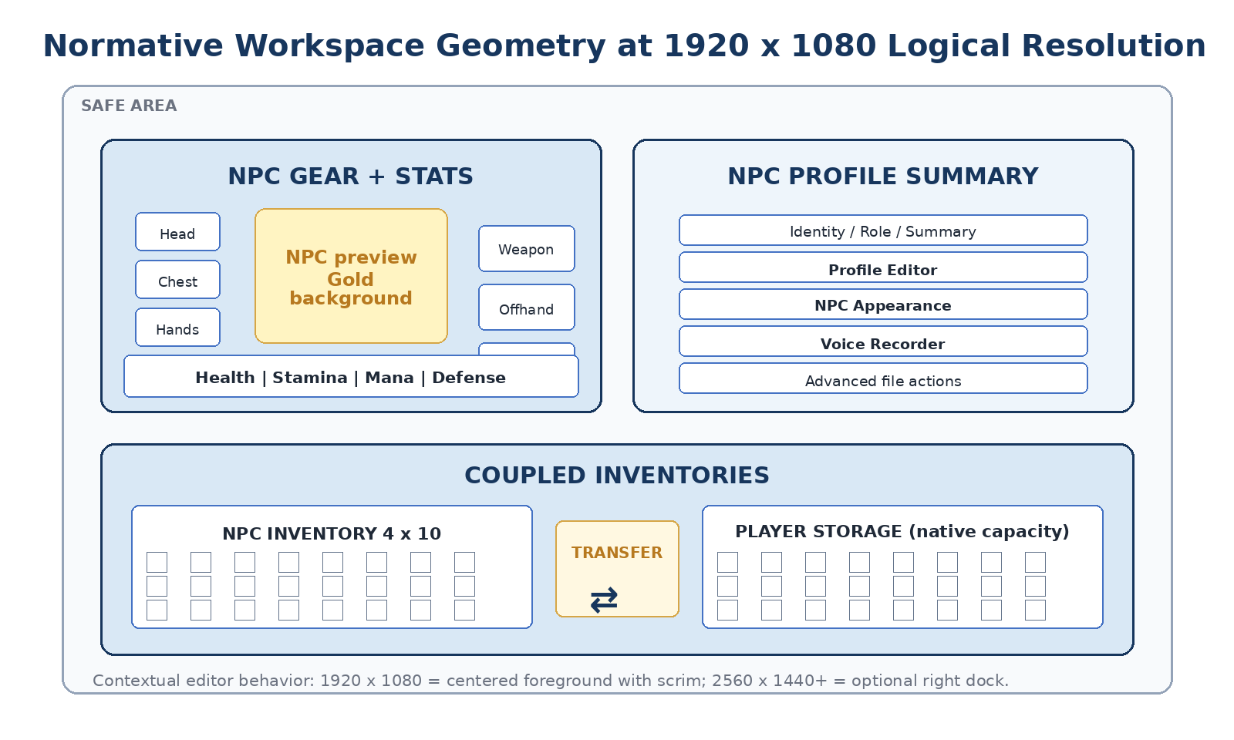
Figure 5. Normative base workspace geometry. Numeric values are starting targets and must be reconciled with current UI scale; alignment and square-slot invariants are mandatory.
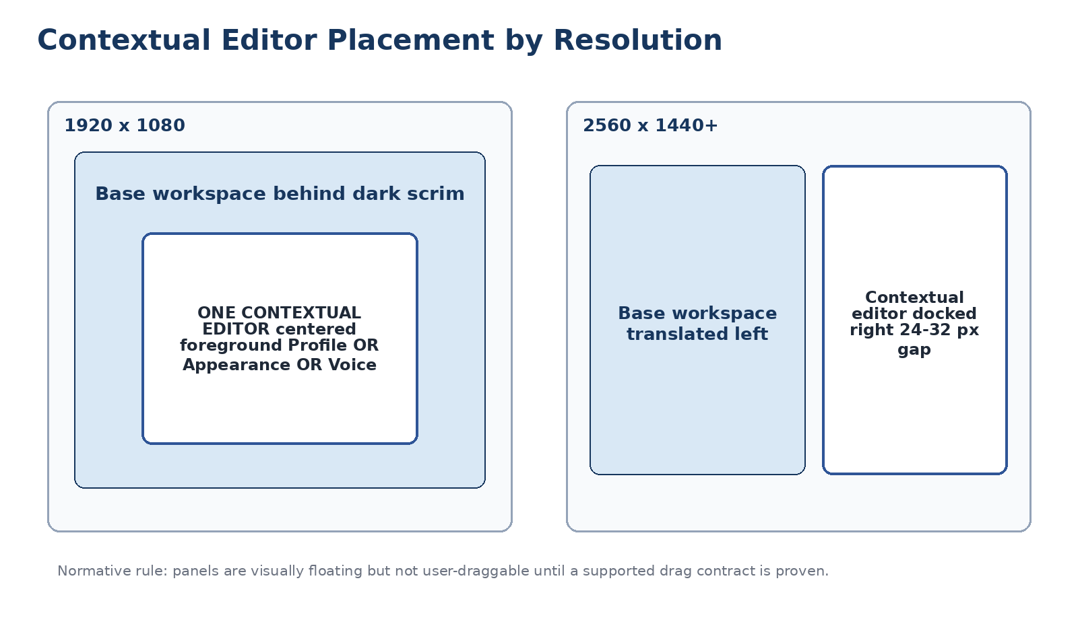
Figure 6. Contextual editor placement. The first implementation manages panel position; it does not promise free user dragging.

11.1 Color and semantic identity
Element | Semantic treatment | Guidance
Player | Cyan/turquoise | Retain Hytale's player-associated visual language where visible
Neutral NPC | Gold/yellow | Use NPCBackground@2x.png behind the NPC preview; do not imply hostile red
Hostile/monster future extension | Crimson/red | Deferred; do not couple current studio behavior to hostility color
Primary action | Hytale blue | Save and Enter are strongest rightmost actions
Warning | Amber/yellow | Recoverable issue, incomplete requirement, or compatibility warning
Error | Red | Rejected mutation or invalid draft; include text, not color alone
Success/ready | Green | Voice ready, valid profile, successful save or rescan

11.2 Panel geometry
Panel | 1920 x 1080 target | Alignment rule | Responsive rule
Gear + Stats | x 160, y 40, w 760, h 510 | Left edge aligns with coupled inventories | Uniformly scale; keep preview and slot columns legible
Profile Summary | x 944, y 40, w 816, h 510 | Right edge aligns with coupled inventories | May narrow text summary before shrinking buttons
Coupled Inventories | x 160, y 574, w 1600, h about 370 | Spans both top panels | Keep slot aspect ratio 1:1 and preserve center rail
Contextual editor | Centered foreground | One editor only | Dock right only when safe width remains
Footer legend | Bottom safe area, about 44 high | Center under workspace | Hide unsupported controls before compressing text

11.3 Square-slot invariant
Inventory and equipment slots must remain square at every supported UI scale. Do not fit the workspace by scaling width and height independently. Use Hytale's current default ItemGrid slot size, spacing, icon scale, quantity placement, durability overlay, and padding where those styles are available to Custom UI. A layout that fits only by producing rectangular cells is rejected.

11.4 NPC presentation assets
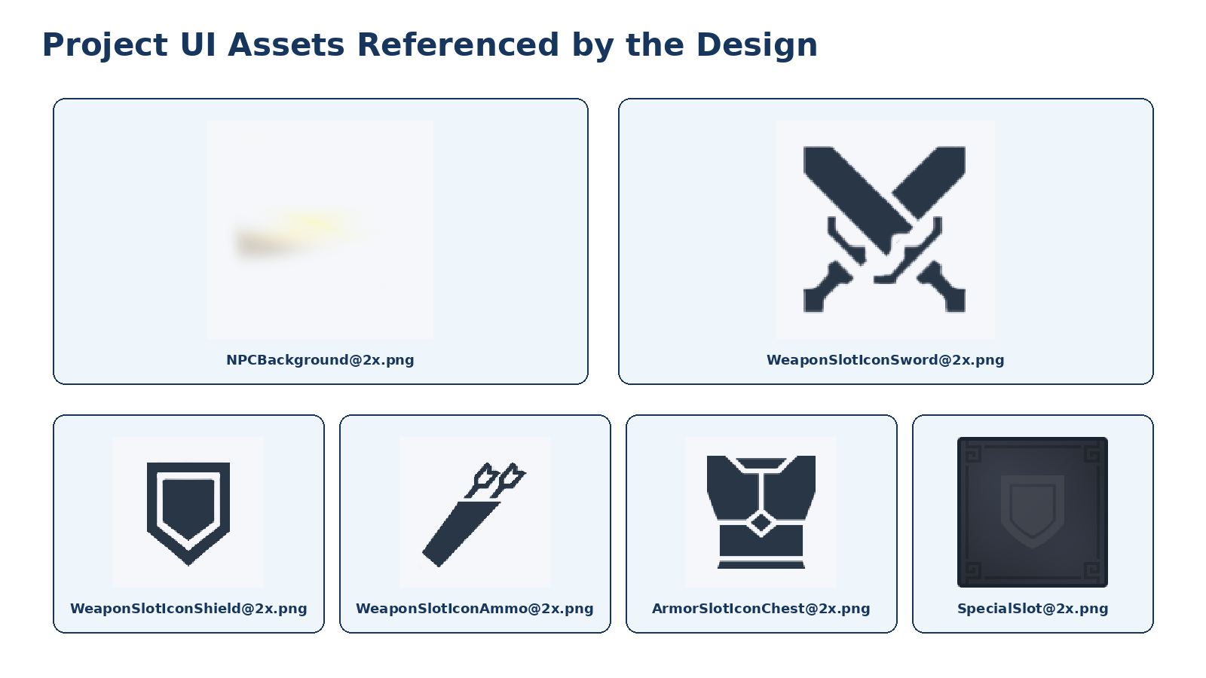
Figure 7. Project assets referenced by the visual design. These files must be packaged under stable mod-relative paths; local developer installation paths are not production dependencies.
- NPCBackground@2x.png: gold/yellow character-preview background.
- WeaponSlotIconSword@2x.png: transparent Primary Weapon semantic overlay.
- WeaponSlotIconShield@2x.png: transparent Shield/Offhand semantic overlay.
- WeaponSlotIconAmmo@2x.png: transparent Preferred Ammunition semantic overlay.
- Armor slot overlays may use compatible project-packaged copies or current mod assets, not hard references into the user's Hytale client installation.
- SpecialSlot@2x.png is a reference for visual treatment; do not assume it is a reusable Custom UI dependency unless packaged lawfully and supported.

11.5 Typography and action ordering
- Use Hytale-compatible sans-serif styling and supported Common.ui components.
- Headers use uppercase or title case consistently within the same panel family.
- Primary save action is rightmost and visually strongest.
- Profile Editor bottom order is exactly: Generate | Reset | Cancel | Save Profile.
- Appearance bottom order is: Randomize | Reset | Cancel | Save Appearance.
- Voice Recorder controls are state-dependent; Save Sample is the final commit action.
- Do not display provider names in creator-facing Generate controls.

12. Workspace Navigation State Machine
Navigation is an explicit state machine, not a collection of independent Visible toggles. The panel manager and session controller own the current editor kind, dirty state, confirmation state, and allowed transitions.
From | Action | Guard | To | Side effects
READY | Open Profile Editor | Writer lease valid | PROFILE_EDIT | Create profile draft and editor generation
READY | Open NPC Appearance | Cosmetics service available | APPEARANCE_EDIT | Create skin draft and preview lease
READY | Open Voice Recorder | Voice permission and input capability | VOICE_EDIT | Create recorder session; capture not yet active
Any editor clean | Open another editor | No unsaved draft | Target editor | Dispose current draft, increment editor generation
Any editor dirty | Open another editor | Creator chooses Save/Discard | Target editor or current | Commit or discard current draft
Any editor | Cancel | If dirty, confirmation | READY | Discard draft and restore authoritative preview
COMMITTING | Save succeeds | Revision still current | READY or same editor | Refresh summary/caches/revisions
COMMITTING | Save fails | Rollback complete | Same editor | Keep draft, show actionable error
READY/editor | Close studio | Dirty editors resolved | CLOSED | Invalidate generations, flush items, release leases

12.1 Navigation rejection
A stale event from a hidden editor, old page generation, closed recording, or prior NPC must be ignored or rejected without changing the active workspace. The page should refresh the affected controls from current state when silence would confuse the creator.

12.2 URL/file browser behavior
Raw file browsing is an advanced/developer function. Opening the profile, skin, or voice folders must never replace the normal authoring workflow. If the operating system cannot open the path, show a non-fatal message and keep the studio session intact.

13. NPC Gear and Stats Panel
The Gear + Stats panel combines a live NPC preview, four armor slots, three loadout slots, one ammunition policy, and authoritative live statistics. Its purpose is to author and inspect the NPC's current embodied state, not merely display decorative cells.

13.1 Panel composition
Region | Content | Behavior
Header | [NAME]'S GEAR or NPC GEAR | Stable title; optional validity icon
Left slot column | Head, Chest, Hands, Legs | Filtered equipment endpoints; eye toggle visible only when occupied
Center | Character preview over gold NPC background | Reflects draft appearance when Appearance Editor active, otherwise authoritative live state
Right slot column | Primary Weapon, Shield/Offhand, Preferred Ammo | Typed loadout endpoints and semantic overlay icons
Ammo policy | Infinite Ammunition checkbox + tooltip | Enabled only when meaningful for selected weapon
Stats strip | Health, Stamina, Mana, Defense | Authoritative snapshot, event/coalesced refresh

13.2 Preview state priority
- If Appearance Editor has an active valid draft, render that draft skin in the studio preview.
- Otherwise render the authoritative saved NPC skin.
- Always overlay the current authoritative equipment/loadout unless the Appearance Editor is explicitly previewing cosmetic conflict behavior.
- Do not let an unsaved profile draft change physical appearance.
- Do not mutate the live NPC for every appearance click; apply the live NPC only after Save Appearance.
- After a committed gear transaction, update both live NPC equipment and studio preview through the validated equipment update path.

13.3 Armor visibility
Each occupied armor slot may expose the established visibility toggle. Visibility is separate typed state and must persist independently from the item. Toggling visibility does not unequip or move the item. An empty slot has no eye control. Compatibility and visibility changes must refresh the preview without changing item ownership.

13.4 Loadout labels and tooltips
- Primary Weapon. Current/preferred combat weapon selected from a compatible item.
- Shield / Offhand. Validated shield or supported offhand item; compatibility is not determined from display names.
- Preferred Ammunition. Explicit ammunition preference or actual loadout stack according to the repository's existing domain model.
- Infinite Ammunition. Tooltip text: "Toggle for infinite ammunition." The checkbox is disabled when no compatible ranged weapon is selected.

13.5 Panel refresh triggers
- Workspace open and live entity rebind.
- Committed armor/loadout move.
- Armor visibility change.
- Saved appearance change.
- Authoritative stat change or coalesced fallback refresh.
- NPC unload/reload or equipment-component replacement.
- Profile role/name change affecting labels only.

14. Coupled Inventory Panel
The inventories belong in one shared visual frame because they form one interaction surface. The left side shows the target NPC's fixed 40-slot storage; the right side shows the viewing player's actual Storage capacity. A narrow transfer rail communicates direction and may later support selected-stack quick moves.

14.1 Authoritative bindings
Surface | Authority | Capacity | Persistence
NPC Inventory | Exact live NPC InventoryComponent.Storage ItemContainer | 40 slots unless current domain migration says otherwise | Existing NpcInventoryRepository listener and terminal flush
Player Inventory | Viewing player's actual Storage ItemContainer | Current Hytale capacity | Hytale player persistence
Transfer rail | No item authority | Two selected-stack actions | None

14.2 Initial item interactions
- Left-click full-stack move to empty slot.
- Internal rearrangement in both grids.
- Compatible stack merge.
- Occupied-slot swap where native transaction semantics support atomic swap.
- Partial split and one-item placement matching proven Hytale semantics.
- Quick move/shift behavior using InventoryUtils.smartMoveItem or current native equivalent.
- Full destination and incompatible destination rejection with authoritative snapback.
- Close while carrying or during a pending event without loss or duplication.

14.3 Transfer arrow rail
The dual-arrow rail is a useful affordance but must not become a shortcut around selection and validation. In the first visual stage, show disabled buttons with tooltips. Activate only after the studio can identify one authoritative selected source stack, the destination policy is unambiguous, and the quick-move path passes the same replay, stale-state, capacity, and persistence gates as drag/drop.
- NPC-to-Player arrow: move selected NPC stack into Player Storage using current pickup/quick-move policy.
- Player-to-NPC arrow: move selected Player stack into NPC Storage, merging only through native transaction behavior.
- Never interpret the arrows as Take All or Put All.
- Disable when no valid selection, wrong direction, stale session, or destination has no capacity.

14.4 Visual synchronization
After every accepted or rejected operation, rebuild affected ItemGrid slot arrays from the authoritative ItemContainers. Do not patch only the cell the client claimed changed. The R116-R119 investigations showed that client presentation can remain stale even after a native transaction and UpdateWindow; the explicit bridge reconciliation remains required. [P9-P11]

14.5 Player-facing status
Internal reason | Player-facing text | UI behavior
AUTHORITATIVE_SOURCE_EMPTY | That item is no longer there. | Refresh both grids; no intrusive modal
DESTINATION_FULL | There is no room for that item. | Refresh and retain source
INCOMPATIBLE_ITEM | That item cannot be placed in this slot. | Highlight destination briefly
STALE_SESSION | The inventory changed. Try again. | Refresh all item surfaces
NPC_UNAVAILABLE | This NPC is no longer available. | Disable live item editing; require reopen
DUPLICATE_EVENT |  | Suppress and refresh silently

15. Server-Authoritative Inventory Transaction Completion
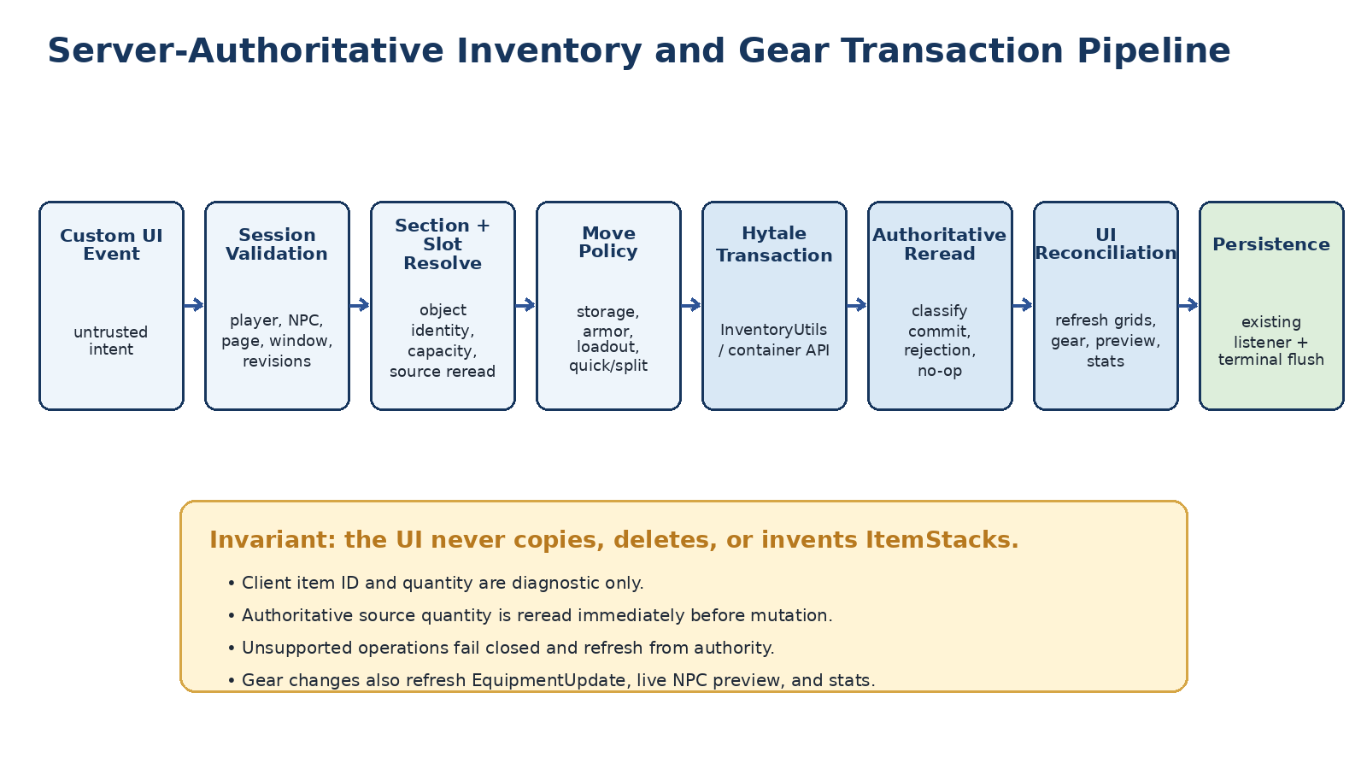
Figure 8. Server-authoritative item pipeline. UI events are intent; Hytale containers and transactions remain the sole mutation authority.

15.1 Generalized bridge
Generalize the current CustomInventoryTransactionBridge only after auditing its current production revision. Prefer a narrow policy composition over a second bridge implementation.
AuthoritativeItemMoveBridge
+ StorageMovePolicy
+ EquipmentMovePolicy
+ LoadoutMovePolicy
+ SplitMovePolicy
+ MergeSwapPolicy
+ QuickMovePolicy
+ UiReconciliationPolicy

15.2 Immutable move intent
record AuthoringItemMoveIntent(
UUID operationId,
UUID sessionId,
long pageGeneration,
UUID viewerPlayerId,
UUID npcStableId,
int sourceSectionId,
int sourceSlotId,
int targetSectionId,
int targetSlotId,
int requestedQuantityDiagnostic,
int mouseButton,
MoveGesture gesture,
long clientEventSequence
) {}
The client-supplied item ID and quantity may be retained for diagnostics, but they never determine mutation. The bridge resolves the source section, rereads the authoritative source ItemStack, derives the allowed quantity from the validated gesture, and lets Hytale's transaction API enforce container filters, stack limits, and legal moves.

15.3 Validation order
- Resolve active authoring session and exact page instance.
- Validate viewer ownership, stable NPC ID, current entity UUID/Ref, and writer permission.
- Validate page generation, window registration, and exact container object identities.
- Allowlist source and target sections for the active domain.
- Validate source and target slot bounds against current capacities.
- Reread authoritative source and target stacks.
- Validate gesture, button, and quantity policy.
- Suppress duplicate/replayed physical releases.
- Execute on the required world thread.
- Call the current native move/smart-move/container transaction.
- Reread all affected containers and classify result.
- Refresh UI from authority and persist through existing listeners.

15.4 Operation semantics
Operation | Preferred native path | Acceptance
Full-stack move | InventoryUtils.moveItem | Exact source removal/target addition or clean rejection
Internal move | InventoryUtils.moveItem | Same section allowed; same-slot becomes no-op
Compatible merge | InventoryUtils.moveItem/container move | Native stack limit and remainder; no local arithmetic writes
Occupied swap | Native atomic swap/move semantics if supported | Both items exchange or operation rejects without mutation
Partial split | InventoryUtils.moveItem with validated quantity | Matches connected Page.Bench behavior
Quick move | InventoryUtils.smartMoveItem or exact native strategy | Deterministic direction limited to Player Storage and NPC Storage

15.5 Replay protection
Custom UI may emit multiple related events for one gesture. Select one mutation trigger and treat all hover/drag-complete/cancel events as observation or reconciliation signals. A short-lived fingerprint includes session, generation, source/target section and slot, authoritative quantity, gesture, and client event sequence. Suppression must be logged without allowing delayed events to mutate a new page.

15.6 Post-operation convergence
- Classify COMMITTED, REJECTED, NO_OP, STALE, INVALID, or DUPLICATE from authoritative post-state.
- Refresh complete source and target slot arrays, not assumed deltas.
- Ensure drag/cursor visual state is cleared through the current proven reconciliation method.
- Flush or queue persistence only through the existing repository listener/terminal flush.
- Record before/after summaries and operation ID without logging sensitive metadata payloads unnecessarily.

15.7 Completion gate
Storage movement is complete only after Player internal, NPC internal, bidirectional transfer, merge, swap, partial split, quick move, full destination, stale source, repeated event, close while dragging, reopen, restart, and at least 100 mixed operations pass with zero loss, duplication, ghost items, wrong-section moves, or wrong-NPC mutations.

16. Gear and Loadout Transaction Architecture
Gear is not a cosmetic overlay on storage. It is a set of authoritative equipment endpoints with stricter compatibility, displacement, preview, stat, and persistence consequences. Implement gear only after the storage bridge is production-green.

16.1 Endpoint graph
Player Storage <-> NPC Armor
NPC Storage <-> NPC Armor
Player Storage <-> NPC Loadout
NPC Storage <-> NPC Loadout
NPC Armor -> Player or NPC Storage on unequip
NPC Loadout -> Player or NPC Storage on unequip
Do not allow armor-to-loadout or loadout-to-armor direct moves unless a future explicit operation defines them. Every endpoint is allowlisted by the active session and the exact current container/window identities.

16.2 Equipment move policy
Stage | Rule
Intent | Dropped/quick-equip event identifies source and semantic target slot; event remains untrusted
Compatibility | Resolve current item asset and validate actual armor/loadout metadata against target
Displacement | If target occupied, use proven atomic swap/displace behavior or reject
Mutation | Call native container transaction; never local copy/remove/add
Post-state | Reread source, target, all equipment containers, and visibility state
Runtime application | Create/apply authoritative EquipmentUpdate and refresh live NPC/preview
Stats | Capture fresh authoritative stat snapshot after equipment update settles
Persistence | Existing equipment/inventory owner records the committed state and terminally flushes

16.3 Armor slots
- Head accepts only items whose authoritative armor slot maps to Head.
- Chest accepts only Chest.
- Hands accepts only Hands.
- Legs accepts only Legs.
- No display-name, icon, category-text, or filename heuristics are sufficient when item metadata is available.
- Armor visibility remains attached to the semantic armor slot, not to the item's current array index.

16.4 Loadout slots
- Primary Weapon accepts a compatible weapon/tool according to current item asset metadata and NPC combat capability.
- Shield / Offhand accepts a real shield or supported offhand item. If the installed build lacks a general offhand contract, define a documented adapter based on actual item configuration.
- Preferred Ammunition accepts or references ammunition compatible with the selected primary weapon under the existing loadout model.
- Changing Primary Weapon must revalidate the Preferred Ammunition and Infinite Ammunition policy.
- Invalid dependent state is not silently deleted. Keep the item authoritative and mark the configuration invalid until the creator resolves it, unless the current domain has a safer established rule.

16.5 Occupied targets and full inventories
The dangerous case is equipping into an occupied target when the displaced item has nowhere to go. Before mutation, establish whether the native transaction can atomically swap or place the displaced item into the source slot. If not, reject the operation. Do not temporarily remove an item and hope a later insertion succeeds. Unequip into full storage should normally reject rather than world-drop.

16.6 Equipment update ordering
- Commit native container transaction.
- Reread equipment and storage authorities.
- Persist/queue the domain change through existing owner.
- Build EquipmentUpdate from authoritative equipment containers using current Hytale API.
- Apply to live NPC on the world thread.
- Update studio preview using its existing validated preview/restoration sequence.
- Capture and publish a fresh stats snapshot.
- Refresh gear cells, inventory cells, visibility buttons, compatibility indicators, and footer controls in one coalesced UI update.

16.7 Failure behavior
- Incompatible item: reject, refresh, and show readable slot-specific message.
- NPC entity changed/unloaded: reject all live gear moves and require reopen.
- Preview update failed after committed equipment move: keep authoritative equipment, mark preview degraded, and retry/rebuild preview without rolling back the item transaction unless the domain contract explicitly requires coupled atomicity.
- Persistence flush failed: retain live authoritative state, surface critical save error, prevent session close from claiming success, and preserve retry/rollback evidence.

17. Equipment Compatibility and Ammunition Semantics
Compatibility must be derived from current item configuration, not assumptions. The Hytale protocol and server asset model expose armor-slot and resistance/stat metadata; the current installed build must be inspected for weapon, projectile, shield/offhand, and ammunition relationships. [H10]

17.1 Compatibility resolver
interface NpcEquipmentCompatibilityResolver {
CompatibilityVerdict validateArmor(Item item, ArmorSlot target);
CompatibilityVerdict validatePrimaryWeapon(Item item, NpcCapabilitySnapshot npc);
CompatibilityVerdict validateOffhand(Item item, Item primaryWeapon, NpcCapabilitySnapshot npc);
CompatibilityVerdict validateAmmunition(Item ammo, Item primaryWeapon);
}
Each verdict should contain a typed reason, evidence describing the item configuration inspected, and whether the conclusion is authoritative, unsupported, or requires review. Avoid silently treating UNKNOWN as compatible.

17.2 Primary Weapon
- Use the item asset's actual weapon/tool configuration and interaction capabilities.
- Validate the NPC has or can receive the required combat capability/animation contract.
- Do not accept arbitrary blocks or consumables because Hytale can render them in hand.
- Do not assume all spears, bows, crossbows, staves, or daggers share identical ammunition/offhand behavior.

17.3 Shield and offhand
The player's native UI visually presents a special shield/offhand region, but a native visual slot is not itself a server-side compatibility rule. Codex must trace current item and interaction metadata. If only shields are reliably classified, version 1 should call the endpoint Shield / Offhand but enable shields first and mark other offhand categories unsupported rather than guessing.

17.4 Preferred ammunition model
Before implementation, inspect the existing NpcInventoryState and loadout persistence. Choose one authoritative model:
Model | Meaning | Rule
Physical loadout stack | Ammo slot owns a real ItemStack consumed during combat | Moving ammo to the slot changes item ownership; no duplicate copy remains in storage
Preference pointer | Ammo slot stores an item-type preference while physical ammo remains in storage | UI clearly distinguishes preference from stack quantity; combat selects matching storage stack

Do not combine the two models. If Hytale's own ranged weapons draw from backpack/storage and do not expose a public multi-ammo priority, the Orbis Preferred Ammunition selection should be explicit and deterministic. If no preference is set, use a documented fallback discovered from the current build or refuse to infer an arbitrary priority.

17.5 Infinite Ammunition
- Infinite Ammunition is a policy flag, not a hidden stack generator.
- Combat authorization checks the policy only after validating a compatible primary weapon and preferred ammunition.
- The setting must not affect Player inventory or ordinary item transfer.
- The UI disables the setting when the loadout cannot use ammunition and shows why.
- Server operators should be able to permission-gate or globally disable the policy in balance-sensitive environments.

17.6 Compatibility invalidation
When a dependency changes, revalidate in this order: Primary Weapon, Offhand, Preferred Ammunition, Infinite Ammunition. An invalid dependent selection should be marked and prevented from gameplay use. Do not silently delete or transfer the item as a side effect of selecting a different weapon.

18. Live Stats Snapshot and Refresh
The Gear panel shows live defensive context so the creator can verify that equipment actually affects the NPC. The values must be captured from current Hytale ECS/stat/combat owners. EntityStatMap exposes live stat values; exact stat IDs and aggregate defense ownership must be audited in the installed build. [H9]

18.1 Stats snapshot contract
record NpcStatsSnapshot(
UUID npcStableId,
UUID npcEntityUuid,
Instant capturedAt,
Optional<StatValue> health,
Optional<StatValue> stamina,
Optional<StatValue> mana,
Optional<DefenseSnapshot> defense,
Map<String, ResistanceValue> optionalResistances,
long equipmentRevision
) {}

18.2 Display rules
- Health shows current / maximum when both are authoritative.
- Stamina and Mana are hidden or marked unavailable when the NPC lacks those stats; do not display fabricated 0/0.
- Defense shows the current authoritative aggregate or a clearly labeled base resistance/stat if no aggregate exists.
- Detailed resistances may be exposed in a tooltip or future expanded panel only when actual damage-class data is available.
- A snapshot includes capture time and equipment revision so stale values can be recognized.

18.3 Refresh strategy
- Capture on workspace open after live entity/equipment binding succeeds.
- Capture after committed gear transaction and resulting equipment application.
- Subscribe to an authoritative stat/equipment change signal when current APIs expose one.
- Otherwise use a low-frequency coalesced refresh while the Gear panel is visible.
- Never poll every frame and never perform expensive traversal from the UI callback.
- Reject snapshot results whose entity UUID, equipment revision, session, or page generation no longer matches.

18.4 Failure behavior
If stats cannot be read, inventory and profile authoring should remain available. The panel shows an unavailable state and logs the exact missing stat or component. Do not treat a missing optional stat as an invalid NPC unless an existing gameplay contract requires it.

19. NPC Profile Summary Panel
The Profile Summary panel is the compact overview and navigation surface. It should answer whether the NPC is valid and ready, expose the three authoring entry points, and keep raw file operations secondary.

19.1 Summary fields
Field | Source | Display rule
Name | Authoritative profile | Primary panel identity
Role / occupation | Authoritative profile | One concise line; hide when absent
Biography summary | Authoritative profile | One or two lines with ellipsis; full text lives in Profile Editor
Profile status | Profile validator | Ready, Incomplete, Invalid, or Read-only
Appearance status | Skin validator / live binding | Ready, Missing, Invalid, or Draft
Voice status | Voice profile scanner | Reference ready plus emotional-sample summary
Inventory / gear status | Live binding and persistence health | Normal, Read-only, Save error, or NPC unavailable

19.2 Primary actions
- Profile Editor. Opens the structured profile authoring window.
- NPC Appearance. Opens the Hytale-cosmetics-backed appearance editor.
- Voice Recorder. Opens the in-game sample recording and playback window.

19.3 Advanced actions
Existing Open, Browse, Rescan, and file-location controls may remain in a collapsed Advanced/Developer section. The normal creator workflow must not require Windows Explorer. Any advanced file action must remain permission-gated, path-contained, non-fatal, and unable to invalidate the active session if the operating system action fails.

19.4 Status refresh
Refresh the summary after each successful domain save, voice rescan, inventory persistence failure/recovery, NPC rebind, and validation result. Do not rebuild the entire studio merely to update one status line; use a coalesced summary patch.

20. Profile Editor Domain Model
Profile Editor exposes meaningful authored concepts rather than raw JSON. It operates on an NpcProfileDraft cloned from the current authoritative profile. The draft retains stable identity, base revision/hash, field-level dirtiness, validation results, generated proposal provenance, and unknown extension data.

20.1 Draft contract
record NpcProfileDraft(
UUID draftId,
UUID sessionId,
UUID npcStableId,
long baseProfileRevision,
String baseCanonicalHash,
NpcProfileEditableFields fields,
Set<ProfileFieldPath> dirtyFields,
Map<String, JsonNode> preservedExtensions,
Optional<GeneratedProfileProposal> proposal,
ProfileValidationReport validation,
long editorGeneration
) {}

20.2 Editable field groups
Group | Example fields | Authority notes
Identity | Display name, title, species/race, age, pronouns, role, occupation, home/base, faction/community IDs | Stable NPC ID is immutable and never edited as display text
Personality | Traits, values, likes, dislikes, fears, boundaries, temperament, moral outlook, work ethic | Stored in existing profile schema or explicit schema extension
Biography | Short summary, full background, major life events, current circumstances | Authored canon after Save Profile
Motivations | Goals, desires, ambitions, obligations, personal stakes | Must map cleanly to existing self-model/profile ingestion
Behavior and speech | Speech style, vocabulary, mannerisms, social preferences, expertise, avoided topics, creator instructions | Does not bypass Epistemic claim authorization
Relationships | Stable target IDs, relationship type, authored history/starting state where supported | Reuse existing relationship authority; read-only until safe editor exists
Advanced | Schema version, optional extension fields, provenance, developer notes | Permission-gated; no raw arbitrary file paths

20.3 Schema ownership
Codex must inspect the current profile schema and map each editor field to an existing typed field before adding new keys. If a required concept is not represented, add a versioned schema extension and migration rather than storing an unstructured duplicate. Do not create fields that conflict with belief, memory, relationship, task, or world-state ownership.

20.4 Stable identity
- npcStableId cannot be edited in Profile Editor.
- Display name may change without changing stable identity.
- Relationships and references use stable IDs with readable display names.
- A profile rename updates file/display conventions only through the existing safe rename path; it must not orphan memory, inventory, voice, skin, or relationships.

20.5 Validation categories
Severity | Meaning | Save behavior
INFO | Suggestion or optional completeness note | Save allowed
WARNING | Potentially weak authoring, missing optional sample, or unresolved reference | Save allowed after clear warning where appropriate
ERROR | Schema invalid, required identity missing, illegal ID/reference, length violation, or incompatible field combination | Save blocked
CONFLICT | Base revision/hash changed since draft open | Save blocked; offer rebase/reload

21. Profile Editor UX, Validation, and Unknown-Field Preservation
The editor should resemble a structured game tool, not a database form. Use category navigation, concise labels, multiline fields where appropriate, inline validation, and a persistent bottom action row.

21.1 Window layout
Region | Content
Header | PROFILE EDITOR - [NAME], close button, dirty indicator
Left category rail | Identity, Personality, Biography, Behavior & Speech, Relationships, Advanced
Main form | Only fields for the selected category; scrollable when necessary
Generation scope | Optional selector for Biography, Personality, Motivations, Speech, or All Allowed Fields
Validation strip | Inline errors/warnings and generated-proposal status
Bottom actions | Generate | Reset | Cancel | Save Profile

21.2 Button semantics
Action | Exact semantics
Generate | Create a structured proposal from the current draft. Do not save, close, or overwrite protected fields.
Reset | Restore the draft to the profile revision captured when the editor opened or last successfully saved.
Cancel | Discard draft and proposal. If dirty, require confirmation. Restore summary and any draft-derived preview.
Save Profile | Validate, detect revision conflict, atomically persist, increment revision, invalidate profile caches, refresh summary, and record audit.

21.3 Unknown-field preservation
Profile Editor must not silently discard profile keys it does not expose. Two acceptable strategies are: use the complete typed current profile model with an extension map; or patch a validated JSON tree at known field paths while retaining all unmodified nodes. A deserialize-edit-reserialize path that loses future/mod-specific keys is rejected.

21.4 Canonicalization
Canonical comparisons must normalize only semantically equivalent representations defined by the domain. The inventory hydration incident in which legacy metadata "{}" and runtime null compared unequal is a concrete warning: canonicalize both sides before equality, and restore pre-operation state if validation fails after mutation. Do not generalize this into aggressive normalization that changes meaningful profile text or JSON.

21.5 Length and content constraints
- Define field-specific length budgets suitable for prompt containment and UI readability.
- Reject control characters, invalid Unicode sequences, and malformed stable-ID references.
- Do not strip creator punctuation or style merely to make generated output easier.
- Separate player-facing biography from developer notes that should never enter normal prompts.
- Preserve provenance indicating human-authored, generated-and-reviewed, migrated, or imported content.

21.6 Atomic save
- Revalidate active session, writer lease, stable NPC ID, and current base revision/hash.
- Build the complete canonical profile candidate with preserved extensions.
- Run schema and semantic validators.
- Write to a temporary sibling file.
- Flush/close and reread/validate the temporary file.
- Create or retain rollback copy according to repository policy.
- Atomically replace the authoritative profile file.
- Increment revision and write audit record.
- Invalidate/rebuild profile, prompt, and NPC self-model caches through existing owners.
- Refresh Profile Summary and reject any late result from the prior revision.

22. Profile Generation Service
NpcProfileGenerationService is a provider-neutral authoring assistant. Its visible action is Generate. It may use the current Orbis model/provider or a future approved authoring provider, but the UI must not expose the implementation model name or make generated prose authoritative.
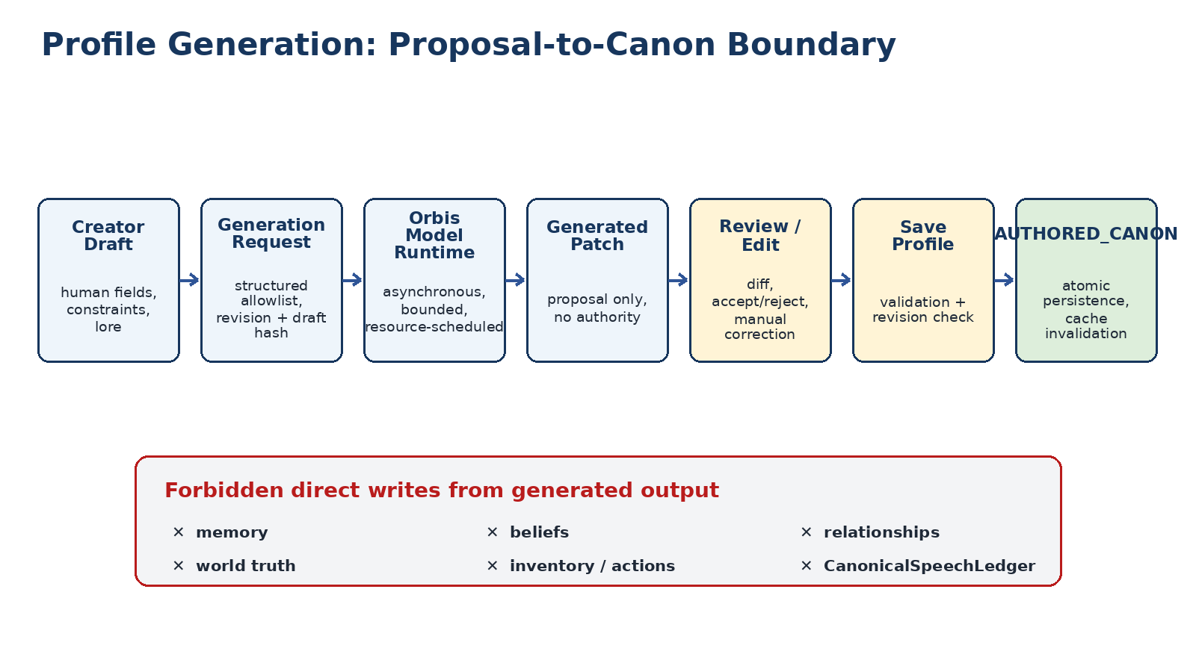
Figure 9. Generated profile content remains a proposal until explicit human review and Save Profile promote it into authored canon.

22.1 Generation request
record ProfileGenerationRequest(
UUID requestId,
UUID sessionId,
UUID npcStableId,
long pageGeneration,
long editorGeneration,
long baseProfileRevision,
String draftHash,
GenerationScope scope,
NpcProfileEditableFields currentDraft,
Optional<WorldLorePacket> approvedLore,
Map<ProfileFieldPath, Integer> fieldBudgets,
String schemaVersion
) {}

22.2 Generation scopes
- Biography only.
- Personality and values.
- Motivations and goals.
- Speech style and mannerisms.
- Fill missing allowed fields.
- Refine selected text without altering facts.
The request should include creator facts and only approved, bounded lore relevant to the task. It should not include broad world state, private player memory, unrelated NPC records, credentials, raw logs, or hidden reasoning.

22.3 Structured output
record GeneratedProfilePatch(
UUID requestId,
UUID npcStableId,
long baseProfileRevision,
String sourceDraftHash,
Map<ProfileFieldPath, ProposedValue> allowedChanges,
List<GenerationWarning> warnings,
ProviderGenerationMetadata metadata,
String schemaVersion
) {}
- The allowlist excludes stable identity, file paths, inventory, gear, live relationships, memory, tasks, schedules, and world-state fields.
- The output must be schema-validated before presentation.
- Malformed, over-budget, or disallowed changes are rejected or quarantined, not partially applied invisibly.
- Do not persist model chain-of-thought. Retain final proposed values, structured warnings, request identity, and provider metadata needed for audit.

22.4 Resource and lifecycle behavior
- Run asynchronously through the existing Orbis resource scheduler with lower priority than active conversation and Hytale-critical work.
- Apply timeout, cancellation, bounded retry, and output budget.
- Cancel on editor close, session close, NPC deletion, provider shutdown, or a newer Generate request.
- Accept output only when session, NPC, editor generation, base revision, and draft hash still match.
- A provider failure degrades Generate only; manual profile editing remains available.

22.5 Proposal application
Present a field-level diff. The creator may accept all, accept selected fields, edit proposed text, or discard. A proposal should not overwrite dirty manual fields without an explicit conflict decision. Accepted proposal values become ordinary draft values with provenance, not canon.

22.6 Generation quality checks
Check | Rule
Fact preservation | Do not contradict creator-supplied identity, relationships, dates, role, or approved lore
No invented current state | Do not claim present possessions, location, tasks, injuries, or relationships unless explicitly authored
No system leakage | Reject prompt text, implementation notes, model identity, or JSON instructions in prose fields
Field scope | Only requested/allowed fields may change
Length | Each proposed value stays within field budget
Tone | May be creative, but must remain compatible with current profile facts and intended setting
Safety | No executable commands, paths, credentials, or hidden control directives

23. Generated Content Provenance and Canon Promotion
Generated authoring assistance intersects Orbis epistemics. The key rule is that a generated proposal is neither NPC memory nor evidence about the world. It becomes authored canon only through the same explicit profile save and ingestion path as manually authored content.

23.1 Provenance states
State | Meaning | May enter Orbis prompt/canon?
HUMAN_DRAFT | Unsaved manual edit | No
GENERATED_PROPOSAL | Unreviewed model output | No
GENERATED_ACCEPTED_DRAFT | Creator accepted/edited proposal in draft | No
AUTHORED_CANON_HUMAN | Human-authored value saved successfully | Yes, through normal profile ingestion
AUTHORED_CANON_GENERATED_REVIEWED | Generated value reviewed and explicitly saved | Yes, marked with provenance
MIGRATED_CANON | Existing data transformed by schema migration | Yes, with migration identity

23.2 Forbidden propagation
- Generate cannot write the belief store.
- Generate cannot create episodic memories.
- Generate cannot modify current relationships or reputation.
- Generate cannot create tasks, schedules, inventory, or action results.
- Generate cannot commit speech into CanonicalSpeechLedger.
- Generate cannot cause the NPC to claim the proposal was experienced or remembered.

23.3 Canon ingestion
- Save Profile atomically commits the profile.
- Profile repository emits or exposes the new revision.
- Existing profile-to-self-model/canon ingestion validates the saved fields.
- Prompt and profile caches are invalidated.
- Future dialogue receives only the saved canonical version.
- Evaluation fixtures may record the change, but the act of generation itself is not testimony or experience.

23.4 Audit record
record GeneratedCanonProvenance(
UUID proposalId,
String providerId,
String providerModel,
String sourceDraftHash,
Set<ProfileFieldPath> acceptedFields,
UUID acceptingPlayerId,
Instant acceptedAt,
long committedProfileRevision
) {}
Store only the provenance needed to explain how saved text was produced. Do not retain hidden reasoning, unnecessary prompts containing private data, or credentials.

24. Appearance Editor Feasibility and API Boundary
The recommended approach is a custom server-driven NPC Appearance Editor inspired by Hytale's My Avatar experience, backed by Hytale's cosmetics data and PlayerSkin representation. Do not attempt to make the native My Avatar controller edit a non-player target unless a future supported API explicitly permits it.
The current protocol PlayerSkin carries body characteristic, underwear, face, eyes, ears, mouth, facial hair, haircut, eyebrows, pants, overpants, undertop, overtop, shoes, head accessory, face accessory, ear accessory, skin feature, gloves, and cape fields. [H7] Community Wardrobe demonstrates that a familiar server-driven cosmetic customization experience is feasible, but its AGPL implementation is reference-only unless license review approves reuse. [C1]

24.1 Feasibility decision
Approach | Status | Decision
Invoke native My Avatar page against NPC | No supported server contract proven | Do not base implementation on it
Custom UI with Hytale cosmetics catalog | Strongly feasible, exact APIs version-sensitive | Recommended
Invent new appearance schema | Unnecessary and incompatible risk | Reject
Edit logged-in player's avatar then export | Current manual workaround only | Replace with NPC-targeted save
Copy community Wardrobe code | License-dependent | Reference architecture only unless approved

24.2 Server API preflight
- Enumerate the exact current CosmeticRegistry API and catalog fields.
- Confirm the server-side skin parse/validation/model-creation functions in the installed build.
- Confirm the existing ImmersiveNPCs skin JSON format and adapter path.
- Confirm CharacterPreviewComponent supports repeated draft updates without mutating the Player.
- Confirm color/gradient/variant information exposed for each cosmetic category.
- Record Hytale build identity and fail closed if a future build changes required codecs or category semantics.

24.3 No player-avatar mutation
The appearance editor targets an NPC-owned draft and saved skin. The player's own skin is used only as the viewer context required by the preview protocol, if necessary. Every open, update, cancel, close, disconnect, and exception path must restore the viewer's original skin/model/equipment state exactly.

25. Cosmetics Catalog Service
NpcAppearanceCatalogService exposes a stable, searchable, paginated view of the current Hytale cosmetic registry. It is a read-only catalog service, not an appearance persistence owner.

25.1 Catalog snapshot identity
record CosmeticCatalogIdentity(
String hytaleBuildId,
String registryRevisionOrHash,
String enabledAssetPackSetHash,
String schemaVersion
) {}

25.2 Catalog entry
record CosmeticOptionDescriptor(
CosmeticCategory category,
String cosmeticId,
String displayName,
Optional<String> iconAsset,
List<CosmeticVariantDescriptor> variants,
List<ColorChoice> colors,
Set<CosmeticCategory> hiddenOrConflictingSlots,
CompatibilityMetadata compatibility,
String sourceAssetPack
) {}

25.3 Category mapping
Primary rail | Secondary categories
Body | Body Characteristic, Underwear, Skin Feature
Face | Face, Mouth, Ears, Eyebrows, Facial Hair
Hair | Haircut and any hair-specific variants
Eyes | Eyes and eye color/gradient options
Clothing | Undertop, Overtop, Pants, Overpants, Shoes, Gloves
Accessories | Head, Face, Ear accessories, Cape

25.4 Loading and cache policy
- Build or refresh catalog off the world/UI callback when API safety allows.
- Cache immutable descriptors by catalog identity.
- Do not send the full catalog in one page update.
- Load one selected category and one page of options at a time.
- Debounce search and cancel stale query results.
- Invalidate catalog when enabled asset packs or Hytale build identity changes.
- Do not persist local developer file paths in descriptors.

25.5 Search
Search should operate over normalized display name, category, source pack, variant labels, and creator-safe tags. It should not require a model call. Results remain filtered to the active secondary category unless the UI explicitly enters global search.

25.6 Asset-pack awareness
Hytale asset packs may extend content, so the catalog must identify source pack and tolerate options being removed between sessions. A saved skin referencing a missing cosmetic is displayed as Missing/Invalid with recovery options; it is not silently replaced on load. [H12]

26. Skin Domain Model, Adapter, and Draft
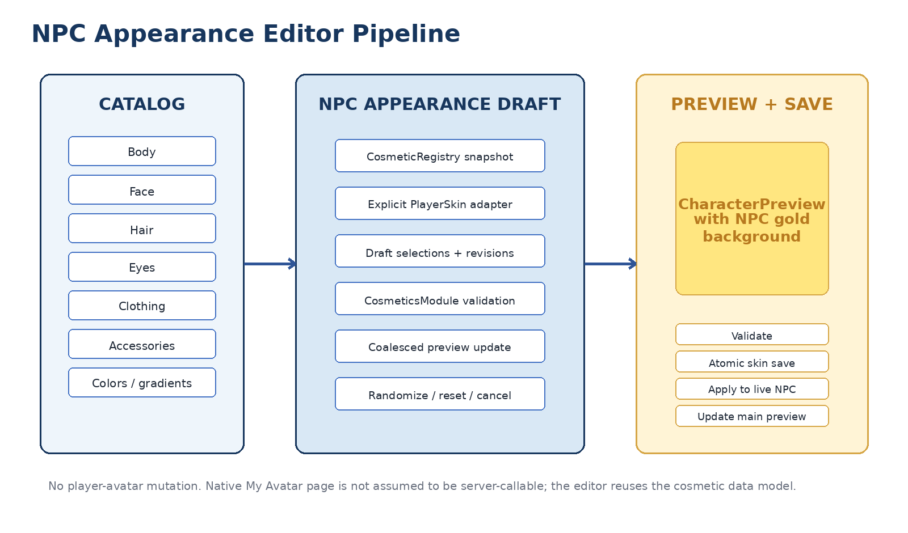
Figure 10. Appearance editing uses a registry-backed draft, explicit PlayerSkin adapter, validated preview, and atomic NPC-targeted save.
Hytale exposes similarly named skin representations across protocol and server cosmetics packages. Add an explicit adapter boundary and fully qualify types at integration points. Community documentation warns against casually mixing these representations. [C2]

26.1 Canonical adapter
interface NpcSkinCodecAdapter {
NpcSkinDocument read(Path authoritativeSkinFile);
ProtocolPlayerSkin toProtocolSkin(NpcSkinDocument document);
NpcSkinDocument fromProtocolSkin(
ProtocolPlayerSkin skin,
NpcSkinDocument extensionPreservingBase
);
SkinValidationReport validate(ProtocolPlayerSkin skin);
String canonicalHash(NpcSkinDocument document);
}

26.2 Appearance draft
record NpcAppearanceDraft(
UUID draftId,
UUID sessionId,
UUID npcStableId,
long baseSkinRevision,
String baseSkinHash,
ProtocolPlayerSkin skin,
Set<CosmeticFieldPath> dirtyFields,
CosmeticSelectionContext selection,
SkinValidationReport validation,
long previewGeneration,
Optional<ProtocolPlayerSkin> resetSnapshot
) {}

26.3 Draft rules
- Opening clones the authoritative saved skin into a draft.
- Every selection produces a new immutable or safely copied draft value.
- Invalid selection never replaces the last valid draft.
- Randomize modifies the draft only and retains a reset/undo snapshot.
- Cancel restores authoritative preview and discards the draft.
- Save Appearance is the only path that changes the saved NPC skin and live NPC appearance.

26.4 Extension preservation
If the current skin JSON contains fields not represented by protocol PlayerSkin, preserve them through the adapter when safe. The adapter must not discard project-specific metadata merely because the appearance editor changes one haircut or color.

26.5 Missing options
When a saved cosmetic ID is absent from the current catalog, retain the original ID in the draft/document, mark the field unresolved, and prevent blind save unless the creator explicitly selects a replacement or the current validator confirms the missing ID is still legal.

27. Appearance UX, Search, Pagination, and Colors
The custom editor should preserve the mental model of Hytale's native avatar creator: primary categories, secondary categories, an option grid, color swatches, a large preview, and clear Randomize/Cancel/Save actions. It need not reproduce the native client page byte-for-byte.

27.1 Window regions
Region | Purpose
Header | NPC APPEARANCE - [NAME], close, dirty/validation indicator
Primary category rail | Body, Face, Hair, Eyes, Clothing, Accessories
Secondary category rail | Registry-backed subcategories for selected primary category
Search and filter | Debounced text search, source-pack filter if needed
Option grid | Paginated or virtualized cosmetic choices with selected and incompatible states
Color area | Valid tint/gradient/variant choices for selected option
Preview area | Large draft NPC preview over gold background, optional rotate/reset controls
Bottom actions | Randomize | Reset | Cancel | Save Appearance

27.2 Option selection
- Creator selects a primary and secondary category.
- Catalog service returns the first bounded page of options.
- Creator selects one option.
- Draft service applies the option to a copy and validates it.
- If valid, increment preview generation and schedule one preview update.
- If invalid, retain current draft and show a human-readable compatibility reason.
- Color/variant controls update to only the choices valid for the selected option.

27.3 Pagination and virtualization
- Do not render hundreds of option cards simultaneously.
- Use a fixed card grid and page controls or virtualized rows supported by current Custom UI.
- Cache display descriptors, not mutable preview models.
- Preload the next page only when inexpensive and cancellable.
- Maintain selection when search/filter changes if the option remains visible/valid.

27.4 Colors and gradients
Render only colors/gradients/variants actually exposed by the cosmetic data. Do not synthesize arbitrary RGB values unless the current Hytale cosmetic contract supports free tinting. Selected color must be encoded in the same skin representation used by validation and preview, not as separate UI-only state.

27.5 Randomize and Reset
- Randomize uses the supported Hytale cosmetics randomization path where available, then validates the result.
- Randomize should respect locked fields in a future extension; version 1 may randomize all supported appearance fields.
- Reset restores the last persisted skin captured at editor open or after the last successful save.
- Neither action changes the live NPC until Save Appearance.

27.6 Accessibility and readability
- Selected state uses border/icon/text in addition to color.
- Every option card has a readable name tooltip.
- Incompatible options show a reason, not only a gray tint.
- Search results and category controls remain keyboard/controller reachable where current Custom UI permits.

28. Appearance Preview, Validation, Save, and Rollback

28.1 Preview update pipeline
- Receive validated draft selection.
- Increment previewGeneration and cancel/coalesce older pending preview work.
- Convert draft through NpcSkinCodecAdapter to the exact protocol/render representation.
- Create or update the preview model through the current supported cosmetics/preview path.
- Apply only if session, editor generation, draft hash, and preview generation still match.
- Retain authoritative live NPC appearance until Save Appearance.

28.2 Preview performance
- Update on committed option click, not mouse hover.
- Coalesce rapid selections to the newest draft.
- Do not create dozens of models concurrently.
- Reuse current preview component and proven viewer restoration sequence.
- Fall back to textual selection if preview generation fails; do not lose the draft.

28.3 Save Appearance
- Revalidate session, writer lease, stable NPC ID, current skin revision/hash, and draft validity.
- Build extension-preserving skin document.
- Write and validate a temporary sibling file.
- Preserve rollback copy or prior content hash.
- Atomically replace authoritative NPC skin file.
- Increment skin revision and audit the commit.
- Apply saved skin to live NPC on world thread.
- Refresh main Gear preview and Profile Summary.
- Invalidate any skin/model cache owned by current runtime.
- Delete temporary files only after successful commit.

28.4 Rollback
If file validation or atomic replacement fails, leave the prior authoritative skin untouched and keep the draft open. If persistence succeeds but live application fails, the saved file remains authoritative; mark live application degraded and retry/rebind rather than silently reverting the saved creator decision without evidence.

28.5 Connected acceptance
- Change each supported category and verify preview.
- Cancel and verify original appearance returns.
- Save, close, reopen, and verify exact skin.
- Restart server/world and verify exact skin.
- Verify live NPC and studio preview agree.
- Verify the logged-in player's avatar is unchanged after every close/error path.
- Verify rapid category changes do not apply stale preview results.
- Verify missing cosmetic/asset-pack removal produces explicit degraded state, not silent substitution.

29. Cosmetic Thumbnail Strategy
Thumbnail generation is the largest appearance-specific UI uncertainty. Do not block the architecture on reproducing native My Avatar thumbnails exactly.

29.1 Priority order
- Use an officially exposed cosmetic icon/thumbnail when the registry/asset provides one.
- Use a project-packaged category silhouette plus the option's readable name when no thumbnail exists.
- Use the large live preview as the definitive visual result.
- Defer generated 3D thumbnail rendering/cache to a separate stage only if usability requires it.

29.2 Deferred generated thumbnail cache
A future thumbnail renderer must be asynchronous, versioned by Hytale build, cosmetic catalog identity, option/variant/color, model renderer version, and asset-pack set. It must not render the entire catalog synchronously when the editor opens. Cache invalidation and disk limits are mandatory.

29.3 License and asset handling
Do not copy third-party cosmetic thumbnails into the mod without permission. Referenced assets remain owned by their source packs. The catalog may display officially exposed icons by their supported asset identifiers; project-authored fallback icons should ship with ImmersiveNPCs.

30. Voice Recorder Feasibility and Capture Authority
The Voice Recorder is feasible only if it reuses Hytale's inbound voice-frame API and the existing Orbis/Chatterbox asset pipeline. It is not a browser microphone widget. The current VoiceModule supports player voice interceptors and direct/entity/positional custom voice streams; exact methods and ordering must be verified against the installed build. [H3-H5]
PlayerVoiceInterceptor is invoked on a shared voice executor off the world thread and must return promptly without blocking, sleeping, file I/O, or contended locks. PlayerVoiceFrame is valid only during the interceptor call. The recorder must therefore copy only the opaque Opus bytes and minimal sequence/timestamp metadata into a bounded queue, then return. [H3, H4]

30.1 Recorder product boundary
- Manual Record, Stop, Play, Delete, and Save Sample controls.
- One selected canonical emotion per recording.
- Clear red recording indicator and elapsed/maximum duration.
- Private draft playback to the recording player.
- Basic waveform or amplitude envelope generated off-thread.
- Quality checks for silence, clipping, duration, channel/sample format, and file validity.
- No trimming timeline, effects rack, multitrack recording, denoising suite, or mastering controls in version 1.

30.2 Canonical emotion set
Emotion | Required? | Fallback/usage
Reference | Required for voice profile | Neutral/Calm/Curious/Whispering and missing emotions fall back here under current mapping
Affectionate | Optional | Tender/Friendly map here
Amused | Optional | Humorous/light delivery
Excited | Optional | High-energy delivery
Angry | Optional | Anger/hostility delivery
Sad | Optional | Sad/grief delivery
Scared | Optional | Uneasy/Afraid map here

30.3 Capture authority
Introduce one capture-lease owner shared with the existing voice/conversation stack. The recorder cannot simply register a second independent microphone consumer, because the same frame could otherwise become both a voice sample and an NPC conversation.
enum VoiceCaptureMode {
NONE,
ORBIS_CONVERSATION,
VOICE_SAMPLE_RECORDING
}
- Only one capture mode may own a player's inbound voice at a time.
- Starting a sample recording fails or pauses cleanly if conversation capture cannot release ownership.
- While recording, frames must not enter Moonshine/STT, dialogue memory, relationship updates, or NPC floor ownership.
- On stop, close, disconnect, or failure, the lease releases deterministically.

30.4 Privacy boundary
The UI must clearly show when recording is active. Where current interceptor ordering permits, recorded frames should be dropped from ordinary proximity relay or delivered only to the recorder pipeline. Because later interceptors may change the audience, Codex must inspect registration priority and document whether private suppression is guaranteed or best-effort in the current build. [H4]

31. Voice Capture Lease and Recording State Machine
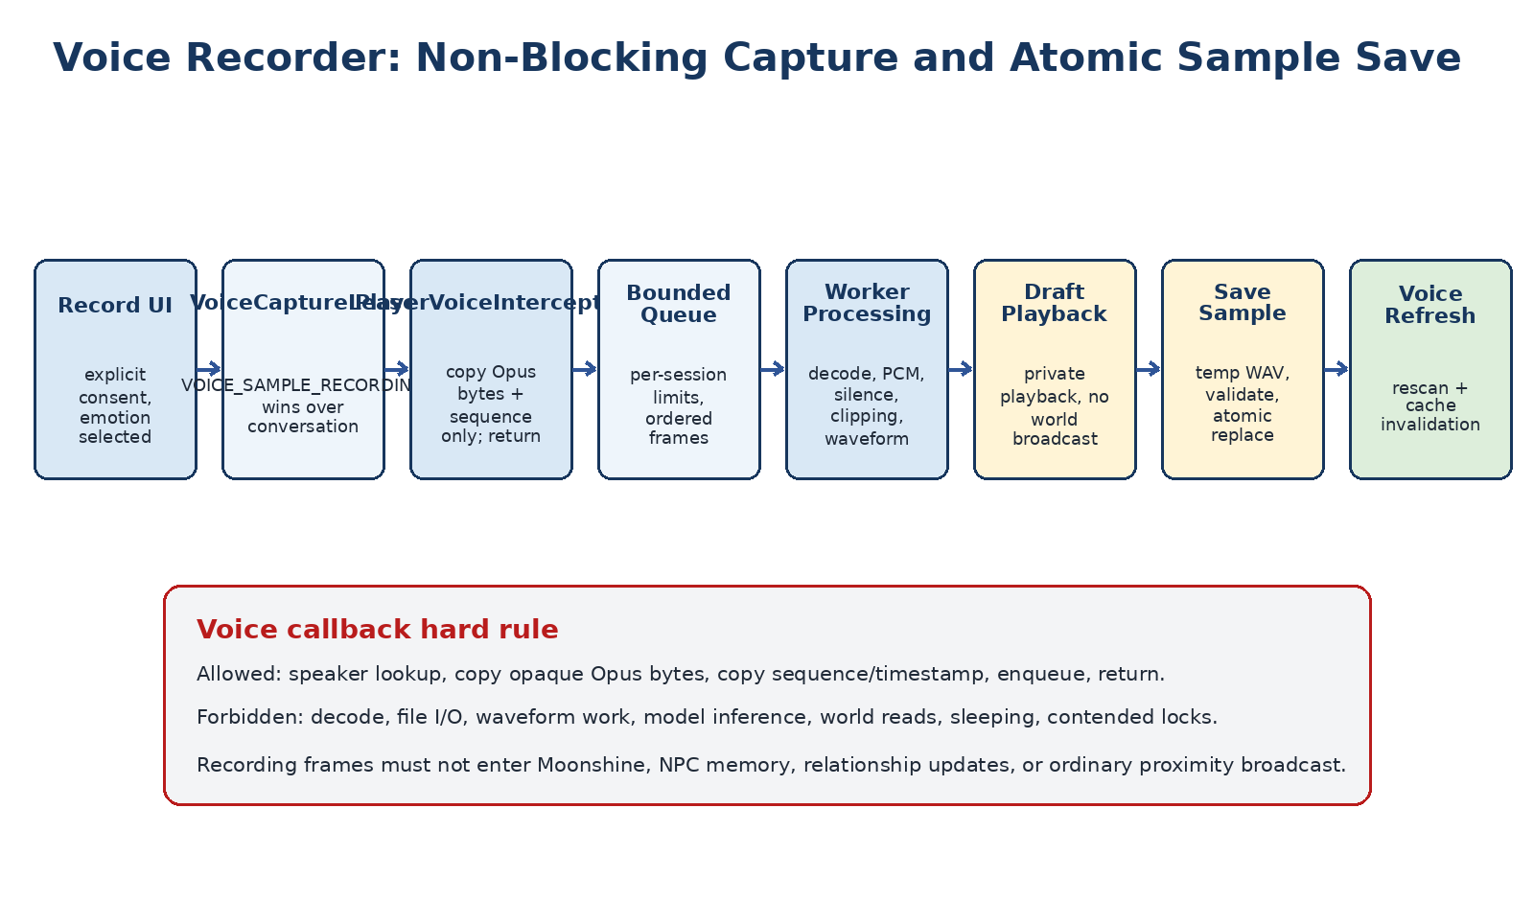
Figure 11. Voice recording pipeline. The voice callback copies bounded frame data and returns; decoding, waveform work, playback preparation, and file writing run off-thread.

31.1 Recording state machine
State | Allowed actions | Exit conditions
IDLE | Select emotion, Record, play/delete saved sample | Record requested
ARMED | Cancel | First valid frame, timeout, input disabled, cancel
RECORDING | Stop | Stop, max duration, disconnect, capture failure
FINALIZING | Cancel only if safe | Decode/analysis succeeds or fails
READY | Record Again, Play, Delete Draft, Save Sample | Action selected
PLAYING | Stop Playback | Playback complete/stop/close
SAVING | No conflicting action | Atomic save succeeds or fails
SAVED | Play, Record Again, Delete Saved | New action or close
FAILED | Retry, discard, close | Creator action
CANCELLED | None | Session disposal

31.2 VoiceRecordingSession
record VoiceRecordingSession(
UUID recordingId,
UUID authoringSessionId,
UUID playerId,
UUID npcStableId,
VoiceEmotion emotion,
long pageGeneration,
long editorGeneration,
long recordingGeneration,
Instant armedAt,
AtomicReference<RecordingState> state,
BoundedOpusFrameQueue queue,
RecordingLimits limits
) {}

31.3 Interceptor algorithm
- Lookup active recording by speaker UUID using a thread-safe read path.
- If no recording is active, return immediately.
- Verify state is ARMED or RECORDING and generation still matches.
- Copy the opaque Opus payload and required sequence/timestamp fields while the frame is valid.
- Apply the chosen audience/drop policy using current interceptor priority.
- Offer the copied frame to a bounded queue without blocking.
- On queue overflow, increment a counter and transition/request failure according to limits.
- Return immediately. Do not touch ECS, files, decoder, waveform, model, or UI.

31.4 Recording limits
Limit | Initial policy | Reason
Maximum duration | Configurable, conservative default aligned with existing voice validator | Bound memory and authoring time
Armed timeout | Fail if no frame arrives within a few seconds | Do not pretend microphone capture started
Queue bytes/frames | Hard bounded per recording | Protect shared voice executor and heap
Sequence gap tolerance | Record and assess; fail only beyond validated threshold | Handle packet loss without hiding unusable audio
Concurrent recordings | One per player; globally bounded | Protect CPU, storage, and voice routing
Temporary lifetime | Delete on session close/failure after bounded cleanup | Avoid orphaned private audio

31.5 Start and stop semantics
- Record. Validate permission, selected emotion, input settings, capture lease, and available temporary storage. Enter ARMED and show Waiting for microphone.
- First frame. Transition to RECORDING and begin elapsed time according to the documented timing policy.
- Stop. Atomically stop frame admission, release capture lease, freeze ordered frame list, and schedule finalization.
- Maximum duration. Behave as an automatic Stop and tell the creator why.
- Close/disconnect. Stop capture, release lease, invalidate generation, discard unsaved audio, and never auto-save.

31.6 Conversation isolation
VOICE ISOLATION. A sample recording must never create an NPC turn, STT transcript, episodic memory, belief, relationship delta, task, action, or canonical speech entry. Recorder playback must not feed back into the same capture path.

32. Audio Processing, Waveform, and Playback
All audio processing begins after frame admission stops or through a bounded streaming worker that never blocks the voice executor. Reuse the current Orbis codec/audio utilities where available. Do not add a parallel decoder stack without first auditing the existing Direct Voice pipeline.

32.1 Finalization pipeline
- Sort/validate copied frames by sequence and timestamp.
- Detect duplicate, missing, or out-of-order frames and produce diagnostics.
- Decode Opus into PCM off-thread.
- Normalize channel layout and sample format to the existing voice-sample validator's required format.
- Compute duration, peak amplitude, clipping percentage, RMS/silence ratio, and bounded waveform envelope.
- Reject empty, too-short, too-long, corrupt, or severely clipped recordings according to explicit thresholds.
- Write only to a temporary draft file or memory-backed draft, never the final sample path.
- Transition to READY and update the UI if the session/generation still matches.

32.2 Waveform representation
record WaveformEnvelope(
int bucketCount,
float[] peakAbs,
float[] rms,
Duration duration,
float clippingRatio,
float silenceRatio
) {}
Use a bounded number of buckets suitable for the UI width. The waveform is diagnostic/presentation data, not the saved audio. Do not send full PCM or raw Opus bytes through Custom UI events.

32.3 Quality feedback
Finding | Player-facing guidance | Save behavior
No frames | No microphone audio was received. Check Hytale voice input. | Blocked
Too short | Record a longer sample with natural speech. | Blocked or warning per current validator
Long silence | Most of the recording is silent. | Warning/blocked by threshold
Clipping | The recording is too loud and may sound distorted. | Warning/blocked by threshold
Sequence gaps | The recording dropped audio frames. | Warning/blocked by severity
Valid | Ready | Save enabled

32.4 Draft playback
Playback of an unsaved draft should be private to the recording player. Prefer replaying the ordered original Opus frames through a direct VoiceSpeaker when that path is safe and preserves timing. If draft PCM must be re-encoded, reuse current codec infrastructure and perform encoding off-thread. Prevent recorder playback from being intercepted as a new recording or normal conversation.

32.5 Saved playback
Playback of a saved sample should reuse the existing voice-sample preview path. Do not load the full Chatterbox model merely to preview a WAV. If only file-level playback exists, keep it separate from TTS conditioning and cache loading.

32.6 Playback lifecycle
- One active recorder playback per session.
- Stop prior playback when a new sample/emotion is selected.
- Stop on close, disconnect, save replacement, delete, or plugin shutdown.
- Late playback completion events may not alter a newer recording generation.

33. Voice Save/Delete and Chatterbox Integration
The existing voice profile and sample repository remains authoritative. The recorder produces a validated draft and delegates naming, path ownership, rescan, and conditioning-cache invalidation to the existing services. Chatterbox uses a reference audio prompt for voice cloning; the exact current Orbis sample format and duration validator remains authoritative over examples in external repositories. [C3]

33.1 Canonical file naming
Emotion | Example file
Reference | jonalith-reference.wav
Affectionate | jonalith-affectionate.wav
Amused | jonalith-amused.wav
Excited | jonalith-excited.wav
Angry | jonalith-angry.wav
Sad | jonalith-sad.wav
Scared | jonalith-scared.wav

Use the existing profile/voice filename sanitizer and path resolver. Never concatenate an unsanitized display name into an arbitrary path. The target must remain inside the owning NPC voice directory after canonical path resolution.

33.2 Save Sample transaction
- Revalidate session, NPC stable ID, selected emotion, permission, base sample revision/hash, and draft validity.
- Resolve the canonical sample target through the existing voice repository.
- Write a temporary WAV beside the target.
- Close, reread, and run the existing voice-sample validator on the temporary file.
- Preserve the prior sample or its hash for rollback.
- Atomically replace the final sample.
- Increment per-emotion/sample revision and write authoring audit.
- Rescan the NPC voice profile.
- Invalidate Chatterbox conditioning/cache identity for the NPC/profile/sample revision.
- Refresh the Voice Samples table and readiness summary.
- Delete draft buffers and temporary files only after success.

33.3 Delete semantics
Action | Confirmation | Result
Delete unsaved draft | Optional simple confirmation | Discard temporary audio only
Delete saved optional emotion | Confirm sample and emotion | Atomic delete/rename-to-trash, rescan, cache invalidation
Delete Reference | Strong warning that voice profile may become invalid | Only with explicit confirmation and permission

33.4 Voice readiness
- Reference missing: voice profile is Missing/Invalid according to current rules.
- Optional emotion missing: fallback to Reference; table shows Missing without invalidating the entire profile.
- Malformed sample: status Invalid with readable validator result.
- Save success: table updates without requiring file browser or manual Rescan, though Rescan remains available.
- Cache failure after valid save: sample remains authoritative; voice runtime reports degraded cache and retries under existing policy.

33.5 Rights and consent
Recording is initiated by the player operating the UI and should display clear consent/recording state. Server operators remain responsible for obtaining appropriate rights for recorded voices and generated use. The studio should store creator/operator identity and timestamp in audit metadata without embedding personal data in the audio filename.

34. Persistence, Revisions, Atomicity, and Migrations
The studio spans four durable authorities: profile JSON, skin JSON, voice WAV files, and NPC inventory/gear persistence. These domains must not share one global Save button because their commit semantics and failure recovery differ.

Figure 12. Persistence and commit boundaries. Explicit-save domains use revisioned atomic file replacement; item domains use immediate native transactions and existing listeners.

34.1 Revision registry
record AuthoringDomainRevision(
UUID npcStableId,
AuthoringDomain domain,
Optional<String> subKey,
long revision,
String canonicalHash,
Instant committedAt,
UUID operationId
) {}
- Profile has one revision/hash.
- Appearance has one revision/hash.
- Voice may use per-emotion sample revision/hash plus aggregate voice-profile revision.
- Inventory/gear use current live state and repository snapshot sequence rather than a long-lived editor draft revision.
- Every asynchronous result carries the base revision/hash it was generated from.

34.2 Atomic file protocol
- Resolve canonical path under the owning NPC directory.
- Validate path containment and permissions.
- Prepare temporary sibling file with unique operation ID.
- Write complete content and close stream.
- Reread and validate temporary content.
- Optionally fsync according to platform/repository policy.
- Preserve existing target through rollback copy or atomic replace semantics.
- Atomically replace target.
- Reread authoritative target, compute canonical hash, and update revision registry.
- Delete obsolete temporary/rollback files according to retention policy.

34.3 Hydration safety
Any hydration that populates an initially empty live container must capture the pre-hydration state. If post-hydration canonical comparison fails, restore the exact pre-hydration state before returning failure. Canonical comparison normalizes only explicitly equivalent legacy representations, such as empty metadata forms already defined by the inventory domain.

34.4 Migration policy
Change type | Required migration behavior
Profile schema adds field | Default absent field without discarding unknown extension data; record migration version
Appearance schema/API changes | Adapter migrates known fields; unresolved cosmetics stay explicit, not silently replaced
Voice naming/emotion mapping changes | Copy/rename only through migration manifest; preserve source and rollback
Inventory metadata canonicalization | Normalize equivalence for comparison and future save; never alter meaningful metadata
Gear/loadout model changes | Versioned conversion with lossless source snapshot and compatibility report

34.5 Crash consistency
- No partially written profile/skin/WAV may become authoritative.
- An interrupted item transaction relies on Hytale's native transaction semantics and repository ordering.
- A crash after file replace but before UI acknowledgment is resolved by rereading authority on reopen.
- A stale queued inventory snapshot may not overwrite a later terminal flush.
- Startup scans quarantine orphaned temporary files and report recovery options; they do not auto-promote unknown content.

34.6 Backup and retention
Retain a bounded number of profile/skin/voice rollback artifacts per NPC or operation history according to configuration. Do not duplicate large audio indefinitely. Audit records should reference hashes and revisions so old content can be correlated without retaining every transient buffer.

35. Threading, Scheduling, and Performance Budgets
The authoring studio is server-driven but crosses multiple executors. Correctness requires explicit thread ownership, bounded queues, cancellation, and Hytale-first resource scheduling.
Work | Required execution context | Budget/constraint
Custom UI event decode | Current page callback; minimal | Validate envelope and enqueue/dispatch quickly
ECS identity/stat read | World thread | Immutable bounded snapshot only
Inventory/gear mutation | World thread/current required store thread | One native transaction, no blocking I/O
Preview apply | Current supported network/world path | Coalesced; reject stale generation
Profile generation | Orbis model worker/resource scheduler | Lower priority than active conversation; timeout/cancellable
Cosmetic catalog indexing | Worker if API-safe; otherwise bounded snapshot on allowed thread | Cache by build/pack identity
Voice interception | Voice executor | Copy/enqueue/return; no decode or I/O
Audio decode/WAV/waveform | Bounded audio worker | Memory and duration limits
Profile/skin/voice file preparation | I/O worker | Atomic protocol; authoritative apply returns to required thread
UI refresh | Custom page command path | Coalesce related fields; avoid full page rebuild for minor updates

35.1 Resource priority
- Hytale server tick and mandatory gameplay work.
- Foreground player-NPC conversation and voice.
- Authoritative inventory/gear transactions and page reconciliation.
- Authoring preview updates and stats refresh.
- Profile Generate requests.
- Catalog prefetch, thumbnail cache, and nonessential analysis.

35.2 Initial performance budgets
Operation | Target behavior
Open base workspace | No long blocking model/audio work; render existing state promptly after identity and container binding
Inventory/gear move | One world-thread transaction and one coalesced authoritative refresh
Stats refresh | Event-driven or low-frequency; never per frame
Appearance option click | UI feedback immediate; newest preview wins; older jobs cancelled
Catalog search | Debounced and paginated
Generate | Asynchronous with visible progress/cancel; gameplay remains responsive
Voice interceptor | Prompt return; bounded enqueue only
Waveform | Bounded buckets; no full PCM in UI payload

35.3 Backpressure
- Only one active Generate request per Profile Editor; newer request cancels older.
- Only one active appearance preview job per editor generation; coalesce to latest.
- Voice frame queue has a hard capacity and fails visibly rather than expanding unbounded.
- Catalog requests are paginated and stale search results are discarded.
- UI refreshes are batched by operation ID/generation.

35.4 Warmup interaction
The studio must not force full Orbis/Chatterbox warmup merely to browse inventory or appearance. Generate and voice-profile rescan may request the specific runtime they need through existing warmup/resource APIs. Manual profile editing and appearance selection should remain usable while models are unavailable.

36. Permissions, Security, Privacy, and Threat Model
Custom UI events, generated output, recorded voice, file paths, inventory sections, and cosmetic identifiers are untrusted until validated. The studio is an administrative/creator surface and must use explicit permissions.

36.1 Suggested permissions
Permission | Controls
immersivenpcs.authoring.open | Open studio and inspect permitted NPCs
immersivenpcs.authoring.profile | Edit and save profile
immersivenpcs.authoring.generate | Use model-assisted Generate
immersivenpcs.authoring.appearance | Edit and save appearance
immersivenpcs.authoring.voice | Record, play, save, and delete voice samples
immersivenpcs.authoring.inventory | Move NPC inventory items
immersivenpcs.authoring.gear | Equip/unequip/loadout changes
immersivenpcs.authoring.advanced | File browser, diagnostics, raw IDs, recovery tools

36.2 Threats and controls
Threat | Control
Forged/stale UI event | Session ID, page/editor generation, viewer ownership, NPC stable ID, action allowlist
Arbitrary inventory access | Allowlist Player Storage and exact active NPC windows/containers by object identity
Item quantity spoof | Ignore client authority; reread source stack and derive quantity server-side
Wrong NPC mutation | Stable ID + current entity UUID/Ref + storage object identity + writer lease
Path traversal | Canonical root resolution and containment check for profile, skin, voice, temp, and rollback paths
Generated prompt injection | Structured output schema, field allowlist, no direct commands/actions, explicit human save
Voice recording without awareness | Visible recording state, deliberate Record action, permission, capture lease
Voice leakage | Interceptor audience/drop policy, private playback, no raw audio logs
Resource exhaustion | Text/audio length limits, queue limits, timeouts, concurrency caps, paginated catalogs
Revision overwrite | Base hash/revision compare and conflict UX
Secret/log leakage | No credentials, hidden reasoning, raw audio, or unnecessary personal content in traces

36.3 Generated-content security
- Generation output cannot select paths, stable IDs, permissions, inventories, gear, or executable actions.
- Strip/reject markup or control syntax capable of escaping the intended profile field representation.
- Do not accept a generated JSON blob directly into profile persistence.
- Model/provider failures cannot disable manual editing.
- Generated content provenance remains visible to operators and auditable after save.

36.4 Voice privacy
- Do not store raw voice in logs or audit records.
- Temporary audio is deleted on cancel/close/failure after bounded cleanup.
- Playback is private to the creator unless an explicit future share function is added.
- Recording should not occur when voice input is disabled or when capture ownership cannot be established.
- Document the limits of suppression if another interceptor can reroute a dropped frame.

36.5 Asset and license boundary
Use official Hytale APIs and project-authored assets. Community Wardrobe is an architectural reference under AGPL-3.0 and must not be copied into a non-compatible project without license review. Chatterbox code/model terms and voice rights must be retained in deployment documentation. [C1, C3]

37. Failure Handling and Recovery
Failures should be contained to the smallest owning domain. A voice decoder failure must not close inventory; a Generate timeout must not invalidate manual profile edits; an appearance preview failure must not corrupt the saved skin.
Failure | Containment | Recovery
Profile validation error | Profile draft only | Keep draft open, mark fields, no file write
Profile revision conflict | Profile save blocked | Reload/rebase or preserve draft recovery
Generate timeout/malformed output | Generation feature only | Discard proposal, retain manual draft
Cosmetic catalog unavailable | Appearance editor degraded | Show saved skin and retry catalog; other domains remain usable
Appearance preview failure | Draft preview only | Retain valid draft, rebuild preview, no live mutation
Skin save failure | Appearance commit blocked | Prior file/live skin retained; draft remains
No voice frames | Recording attempt only | Release lease, show input guidance, no file
Voice queue overflow/decode failure | Recording attempt only | Discard invalid draft, preserve saved sample
Inventory stale source | One move rejected | Refresh grids from authority
Gear incompatible/full displacement | One gear move rejected | Refresh gear/inventory; no mutation
Persistence flush failure | Owning domain critical | Keep session/error visible; retain retry/rollback evidence
NPC unload | Live domains unavailable | Disable live controls; require rebind/reopen
Player disconnect/page close | Whole session | Invalidate generations, stop capture/playback, discard drafts, flush items

37.1 Idempotent close
- Mark session closing and stop admitting events.
- Invalidate page/editor/recording/preview generations.
- Cancel Generate/catalog/preview/audio jobs.
- Stop voice capture and playback; release capture lease.
- Discard unsaved profile/appearance/voice drafts.
- Unregister inventory/stat/voice listeners.
- Terminally flush current inventory/gear persistence.
- Restore viewer preview/model/skin/equipment state.
- Release NPC writer lease and session registry entry.
- Log final cleanup counts. Repeated close calls do nothing harmful.

37.2 Recovery artifacts
Temporary profile/skin/voice files and rollback copies use operation IDs and remain under dedicated roots. Startup recovery scans may quarantine orphaned artifacts and report them; they must not silently promote a temporary file over a valid authoritative file.

37.3 Fail-open versus fail-closed
Concern | Policy
Profile/skin/voice save | Fail closed: no authority change on validation/conflict/write failure
Inventory/gear mutation | Fail closed: no manual fallback copy; refresh authority
Stats unavailable | Fail open for other editor features; show unavailable
Generate unavailable | Fail open for manual profile editing
Appearance preview unavailable | Fail open for draft editing only if selections can still be validated; otherwise read-only
Voice privacy cannot be guaranteed | Fail closed for recording unless operator policy explicitly accepts documented limitation

38. Observability and Diagnostics
Diagnostics must make it possible to trace one authoring action from UI intent through validation, native mutation or file commit, UI refresh, and persistence without exposing raw technical codes to ordinary creators.

38.1 Operation correlation
AuthoringOperationContext
operationId
sessionId
viewerPlayerId
npcStableId
pageGeneration
editorKind
editorGeneration
domainRevisionBefore

38.2 Structured markers
Prefix | Examples
NPC_AUTHORING_SESSION_* | OPEN, READY, EDITOR_SWITCH, CLOSING, CLOSED, REJECTED
NPC_AUTHORING_PROFILE_* | DRAFT, GENERATE_REQUEST, PROPOSAL, VALIDATION, SAVE, CONFLICT
NPC_AUTHORING_APPEARANCE_* | CATALOG, SELECT, PREVIEW, VALIDATION, SAVE, APPLY
NPC_AUTHORING_VOICE_* | ARMED, FRAME_DROP_COUNT, FINALIZE, PLAYBACK, SAVE, DELETE
NPC_AUTHORING_ITEM_* | INTENT, VALIDATED, NATIVE_MOVE, RESULT, REFRESH, DUPLICATE
NPC_AUTHORING_STATS_* | SNAPSHOT, UNAVAILABLE, REFRESH
NPC_AUTHORING_RECOVERY_* | TEMP_QUARANTINE, ROLLBACK, FLUSH_FAILURE, CLEANUP

38.3 Trace contents
- Stable IDs, revisions, hashes, section/slot IDs, operation result, timings, and typed rejection reason.
- Before/after item summaries sufficient to prove quantity and identity without dumping sensitive arbitrary metadata.
- Generated proposal field paths and hashes, not hidden reasoning.
- Voice frame counts, gaps, duration, clipping/silence metrics, and file hashes, not raw audio.
- Preview/catalog generations and stale-result rejection.
- Cleanup/lease/listener counts.

38.4 Developer UI
Developer mode may expose stable IDs, revisions, provider status, file hashes, live binding identity, and raw technical rejection codes. Normal mode uses human-readable status. Do not make developer diagnostics part of the profile canon or prompt.

39. Test Architecture and Connected Validation
Automated tests prove contracts, serialization, permissions, revisions, and server-side state. Connected Hytale tests remain authoritative for Custom UI hit testing, cursor reconciliation, preview behavior, microphone delivery, private playback, UI scale, and native item semantics.

39.1 Test layers
Layer | Purpose | Examples
Unit | Pure domain rules | Draft diff, canonical hash, validation, compatibility, filename/path containment
Component | Repository/service behavior | Atomic save, revision conflict, catalog cache, voice queue, item policy
Fault injection | Rollback and cancellation | Write failure, stale generation, decoder failure, queue overflow, provider timeout
Deterministic integration | Cross-service contracts without client | Session registry, bridge validation, profile/skin/voice commit flow
Connected client | Real Custom UI and Hytale runtime behavior | Inventory drag, preview, category UI, microphone, playback, scaling
Soak | Long-run convergence and resource cleanup | 100+ item ops, repeated editor navigation, recording cycles

39.2 Base workspace connected matrix
- 1920 x 1080 and 2560 x 1440.
- Supported UI scale settings.
- Long and short NPC/player names.
- Spawned and non-spawned target.
- Open, contextual editor switch, Cancel, close, reconnect, and repeated reopen.
- Preview restoration and no Player appearance/equipment mutation.
- Square inventory/gear slots and no panel overlap/clipping.

39.3 Inventory and gear matrix
Case | Required result
Player internal / NPC internal | Correct authoritative rearrangement and refresh
Player <-> NPC full stack | Correct bidirectional ownership, quantity, metadata, persistence
Partial split / one item | Matches proven Hytale semantics
Merge | Native max stack/remainder
Occupied swap | Atomic legal swap or clean rejection
Quick move arrows/shift | One selected stack, deterministic destination, no Take All
Full destination | Reject, retain source, readable message
Incompatible armor/loadout | Reject before mutation, explain slot
Unequip to full storage | Reject without deletion/world drop
Close while carrying | Authoritative/UI convergence, no ghost item
NPC unload/switch/stale event | No wrong-NPC mutation
Restart | Exact inventory/gear/visibility/ammo policy persists
100+ mixed operations | Zero loss, duplication, stale cursor, wrong slot/section

39.4 Profile generation matrix
- Manual edit/save/reopen/restart.
- Generate returns structured allowed fields only.
- Generated proposal does not save automatically.
- Accept selected fields, edit proposal, discard proposal.
- Stale proposal rejected after draft changes or editor close.
- Provider timeout/unavailable leaves manual draft intact.
- Unknown profile fields survive save.
- Revision conflict preserves draft and blocks overwrite.
- Saved generated text is marked reviewed provenance and appears in later Orbis profile context only after save.

39.5 Appearance matrix
- Every exposed category and color/variant path.
- Search, pagination, selected state, incompatible state.
- Rapid selections and stale preview cancellation.
- Randomize, Reset, Cancel, Save.
- Save/reopen/restart and live NPC/main preview parity.
- Missing cosmetic after asset-pack change.
- No logged-in Player avatar mutation.
- No discarded unknown skin extension data.

39.6 Voice matrix
Case | Required result
Input disabled / no frames | Clear failure, lease released, no file
Reference and each emotion | Record, finalize, play, save, table refresh
Silence / clipping / too short | Quality result and save policy
Max duration | Automatic stop and bounded processing
Rapid Record/Stop | Valid state transitions, no stuck lease
Close/disconnect while recording | Capture stops, temp deleted, no auto-save
Private playback | Only creator hears; no recorder feedback
Conversation isolation | No STT, memory, relationship, or NPC response
Replace/delete sample | Atomic, confirmation, rescan, cache invalidation
Reference delete | Strong warning and resulting readiness correct
Repeated cycles | No leaked buffers, speakers, files, or registrations

39.7 Critical invariants asserted by tests
- UI never writes authority directly.
- One session/editor/capture lease owner at a time.
- Stable NPC identity and domain revisions are checked at every mutation boundary.
- No generated proposal reaches canon before Save Profile.
- No voice draft reaches final path before validation and Save Sample.
- No inventory/gear operation uses manual copy/delete.
- No asynchronous stale result updates the current session.
- Every failed commit leaves prior authority intact or restores pre-operation state.

40. Bounded Implementation Program
Implement in eight stages A0-A7. Codex may combine adjacent repository work where practical, but activation and connected gates remain separate. A later stage cannot claim completion while an earlier required gate is red.
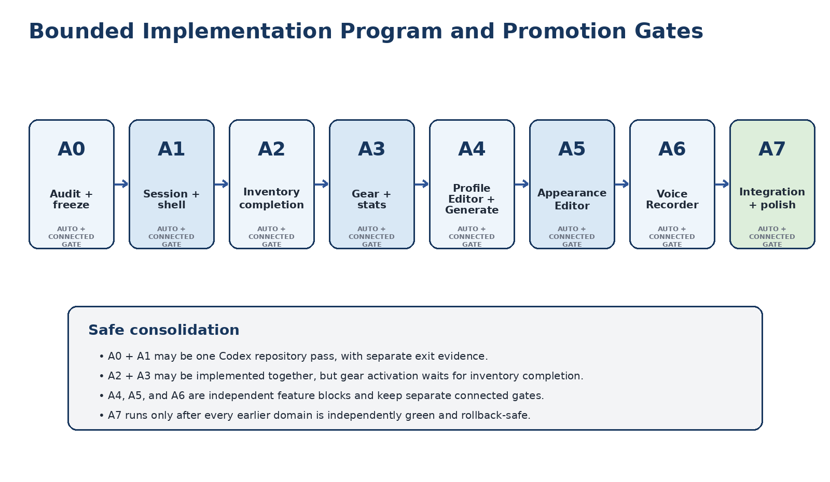
Figure 13. Bounded implementation program. Safe consolidation accelerates coding without collapsing evidence or promotion gates.

40.1 Stage A0 - Repository audit and production freeze
- Inspect current revision, current Npc Profile layout, inventory bridge capabilities, gear/loadout owners, skin/preview path, voice sample repository, Orbis model scheduler, voice interception, stats, permissions, and persistence.
- Record installed Hytale client/server build and relevant API signatures.
- Hash current production classes/assets/JAR and preserve rollback.
- Run current deterministic and connected baseline relevant to NPC Profile.
- Produce ownership map and gap report. Do not change behavior.
Exit gate: current behavior proven, ownership resolved, rollback valid, no production mutation.

40.2 Stage A1 - Unified session and floating workspace shell
- Implement NpcAuthoringSessionRegistry, writer lease, event envelope, panel manager, base panel separation, responsive profiles, contextual editor host, scrim, and navigation.
- Package NPC background and weapon/offhand/ammo icons.
- Keep current inventory, preview, gear shell, profile summary, voice table, and persistence behavior unchanged.
- Contextual editors may show bounded placeholders only.
Connected exit gate: workspace opens at target resolutions, panels do not overlap, slots remain square, current inventory transfers and preview restoration remain green.

40.3 Stage A2 - Complete coupled inventory
- Generalize the production item bridge.
- Enable internal moves, merge, atomic swap or rejection, partial split, quick move, transfer arrows, stale/replay handling, and readable errors.
- Retain native ItemContainer/InventoryUtils authority and explicit UI reconciliation.
- Run full mixed-operation and restart persistence matrix.
Exit gate: complete storage matrix and 100+ operation soak with zero loss, duplication, ghost item, stale cursor, wrong slot/section, or wrong NPC.

40.4 Stage A3 - Gear, loadout, and live stats
- Implement compatibility resolver and equipment endpoints.
- Enable armor, Primary Weapon, Shield/Offhand, Preferred Ammunition, Infinite Ammunition, visibility controls, EquipmentUpdate, live preview, and stats snapshot.
- Keep occupied/full destination behavior atomic or fail closed.
- Persist and verify restart behavior.
Exit gate: every supported equip/unequip direction, compatibility, displacement, preview/live parity, stats refresh, and persistence pass with zero item loss.

40.5 Stage A4 - Profile Editor and Generate
- Implement schema-preserving draft editor, validation, revision conflicts, Generate service, structured proposal/diff, provenance, atomic Save Profile, and summary refresh.
- Do not change Orbis truth, memory, relationship, or speech ownership.
- Evaluate generated output with bounded fixtures and connected manual scenarios.
Exit gate: manual and generated-reviewed save flows survive close/reopen/restart; unknown fields and canon boundaries remain intact.

40.6 Stage A5 - NPC Appearance Editor
- Implement current-build cosmetics audit, catalog service, PlayerSkin adapter, category rails, search/pagination, colors/variants, draft validation, preview, randomize/reset/cancel/save, live apply, and rollback.
- Use placeholders when thumbnails are unavailable.
- Never mutate Player avatar.
Exit gate: all categories and lifecycle cases pass; saved skin survives restart and live NPC/main preview agree.

40.7 Stage A6 - Voice Recorder
- Implement capture lease, interceptor, bounded queue, state machine, off-thread decode/analysis, waveform, private playback, save/delete, rescan, cache invalidation, and privacy/consent UI.
- Reuse existing Direct Voice/Chatterbox assets and codec ownership.
- Test all emotions and lifecycle failures.
Exit gate: real connected microphone capture, private playback, save/reopen/restart, conversation isolation, and repeated-cycle resource cleanup pass.

40.8 Stage A7 - Full integration and polish
- Create a new NPC entirely in game and update an existing NPC through all domains.
- Verify Orbis consumes the saved profile, appearance, voice, inventory, gear, and stats context correctly.
- Run cross-domain stale-session, concurrent editor, disconnect, unload/reload, provider unavailable, missing asset, and persistence failure scenarios.
- Polish spacing, responsive scaling, tooltips, localization, accessibility, and footer help.
- Decide whether the native inventory fallback may be retired; retain it if any Custom UI path remains less reliable.
Exit gate: complete Definition of Done, full deterministic suite, connected matrix, soak, one production JAR, documented rollback.

40.9 Safe stage consolidation
Combined Codex pass | Permitted | Mandatory stop
A0 + A1 | Yes. Audit/freeze and shell/session implementation can be one repository session. | Do not deploy shell if baseline or ownership audit is unresolved.
A2 + A3 implementation | Yes, shared bridge/compatibility code may be built together. | Do not activate gear until storage completion gate is green.
A4 | Prefer independent. | Do not proceed if schema preservation or canon provenance is unresolved.
A5 | Prefer independent. | Do not proceed if current cosmetics API/adapter cannot validate and round-trip.
A6 | Independent. | Do not proceed if capture privacy/threading cannot be bounded.
A7 | Final only. | No integration claim while any domain gate remains connected-pending.

40.10 Required stage report
Maintain NPC_AUTHORING_STUDIO_TECHNICAL_DESIGN_AND_IMPLEMENTATION_REPORT.md with stage status, current revision, automated gate, connected gate, deployed/rollback JAR hashes, ownership decisions, files/classes/assets changed, known limitations, and next allowed stage.

41. Definition of Done
The NPC Authoring Studio is complete only when a creator can perform the entire workflow in game and every domain remains authoritative, durable, reversible, and correctly consumed by Orbis.
- Run /npc create [name] and receive one valid authoring session.
- See separate Gear/Stats and Profile panels plus one coupled Inventory panel with square native-style slots.
- Move, rearrange, split, merge, swap, and quick-move items between Player and NPC without loss or duplication.
- Equip and remove armor, Primary Weapon, Shield/Offhand, and Preferred Ammunition through validated native transactions.
- Configure Infinite Ammunition without generating or duplicating visible stacks.
- See the studio preview, live NPC equipment, and authoritative live stats update.
- Open Profile Editor, manually define the NPC, and preserve unknown profile data.
- Select Generate, review/edit a structured proposal, and save only through Save Profile.
- Confirm generated text becomes authored canon only after save and never becomes memory/world truth by itself.
- Open NPC Appearance, browse the Hytale-backed catalog, select cosmetics/colors, preview, cancel/reset/randomize, and save directly to the NPC.
- Verify the Player avatar never changes.
- Open Voice Recorder, record, stop, privately play, delete, and save Reference and emotional samples.
- Verify recorded speech never becomes an NPC conversation or memory.
- Close/reopen and restart the server; confirm profile, skin, voice, inventory, gear, visibility, ammo policy, and stats-relevant equipment remain correct.
- Converse with the NPC and confirm Orbis uses the saved profile and voice.
- Complete the workflow without raw JSON editing, player-avatar export, Audacity, or manual file movement.
- Pass all deterministic, fault-injection, connected Hytale, resolution/UI-scale, and soak gates.
- Finish with zero item loss, duplication, wrong-NPC mutation, stale preview, leaked capture, uncommitted canon, or partial-file corruption.
FINAL AUTHORITY CHECK. A feature is done only when the creator-facing UI, authoritative server state, durable persistence, live NPC representation, and Orbis consumption all agree after close, reconnect, unload/reload, and server restart.

Appendix A. Proposed Component Map
Names are normative responsibilities, not mandatory exact class names. Codex must map them onto the current repository and avoid introducing a duplicate when an equivalent owner already exists.
Package area | Component | Responsibility
ui | NpcAuthoringStudioPage | InteractiveCustomUIPage shell; build, event dispatch, close lifecycle
ui | NpcAuthoringPanelManager | Floating panel visibility, geometry profile, scrim, contextual editor host
ui | NpcAuthoringUiRenderer | Typed UI patches from immutable view models
ui | NpcAuthoringEventCodec | Versioned central Custom UI event envelope
session | NpcAuthoringSession | Viewer/NPC/page/editor identity, revisions, leases, dirty state
session | NpcAuthoringSessionRegistry | One session per player and one writer lease per NPC
session | NpcAuthoringWriterLease | Exclusive authoring lease and conflict metadata
profile | NpcProfileDraftService | Clone, edit, reset, validate, preserve unknown fields
profile | NpcProfilePersistenceService | Revision check and atomic profile save
profile | NpcProfileGenerationService | Asynchronous provider-neutral structured proposal generation
profile | GeneratedProfileProposalValidator | Allowlist, budgets, schema, fact-preservation checks
profile | ProfileCanonPromotionService | Existing profile/canon ingestion and cache invalidation adapter
appearance | NpcAppearanceCatalogService | CosmeticRegistry snapshot, search, pagination, variants/colors
appearance | NpcSkinCodecAdapter | Explicit stored/server/protocol PlayerSkin conversion and hash
appearance | NpcAppearanceDraftService | Draft selections, validation, randomize/reset, dirty fields
appearance | NpcAppearancePreviewService | Coalesced draft preview generation/application
appearance | NpcAppearancePersistenceService | Atomic skin save, rollback, live apply
voice | VoiceCaptureLeaseManager | Mutual exclusion between conversation and sample recording
voice | NpcVoiceRecordingService | Recording state machine and active session registry
voice | BoundedOpusFrameQueue | Per-recording bounded copied-frame queue
voice | VoiceDraftProcessor | Decode, PCM normalization, silence/clipping, waveform, temp WAV
voice | VoiceDraftPlaybackService | Private playback and lifecycle
voice | NpcVoiceSamplePersistenceService | Canonical naming, atomic save/delete, rescan, cache invalidation
item | AuthoritativeItemMoveBridge | Shared validation, replay protection, native move, reread, refresh
item | StorageMovePolicy | Storage endpoint and gesture rules
item | EquipmentMovePolicy | Armor/loadout endpoint and displacement rules
item | SplitMovePolicy | Validated partial-stack semantics
item | MergeSwapPolicy | Native merge/swap handling
item | QuickMovePolicy | Selected-stack transfer rail and shift/smart-move behavior
item | UiReconciliationPolicy | Authoritative grid/gear/cursor refresh
gear | NpcEquipmentCompatibilityResolver | Armor, weapon, offhand, ammunition compatibility
gear | NpcEquipmentRuntimeApplier | EquipmentUpdate/live NPC/preview application
stats | NpcStatsSnapshotService | World-thread authoritative live stats snapshot
persistence | AuthoringDomainRevisionRegistry | Profile/skin/voice revisions and canonical hashes
persistence | NpcAuthoringAtomicFileWriter | Temp, validate, atomic replace, rollback
audit | NpcAuthoringAuditLog | Append-only authoring operation audit without raw voice
security | NpcAuthoringPermissionService | Domain permissions and NPC scope
integration | OrbisAuthoringGenerationAdapter | Existing provider/resource scheduler adapter
integration | OrbisAuthoringCacheInvalidator | Profile/voice/skin dependent cache invalidation

A.1 Suggested package layout
com.inigmasgames.persistentnpcs.authoring
/ui
/session
/profile
/appearance
/voice
/item
/gear
/stats
/persistence
/audit
/security
/integration
/diagnostics
Do not force every component into a new package if current repository ownership would be clearer by extending an existing profile, voice, inventory, or UI package. The key requirement is dependency direction: UI -> session/domain service -> current authority adapter, never authority -> UI.

Appendix B. Normative Data Contracts
These contracts define required information and trust boundaries. Exact Java records/codecs may differ to match the repository's serialization conventions.

B.1 Central UI event envelope
record NpcAuthoringEvent(
String schemaVersion,
UUID sessionId,
long pageGeneration,
UUID npcStableId,
NpcAuthoringEditorKind editorKind,
long editorGeneration,
String action,
String target,
String rawPayload
) {}
- All values are untrusted until resolved against the active session.
- Server-authored event bindings should provide constants such as target domain and destination section where possible.
- Unknown schema version or action fails closed.

B.2 Session
final class NpcAuthoringSession {
NpcAuthoringSessionIdentity identity;
AuthoringSessionState state;
NpcAuthoringEditorKind activeEditor;
Optional<NpcProfileDraft> profileDraft;
Optional<NpcAppearanceDraft> appearanceDraft;
Optional<VoiceRecordingSession> voiceDraft;
AuthoritativeInventoryBinding inventoryBinding;
AuthoritativeEquipmentBinding equipmentBinding;
AuthoringDomainRevisionSnapshot revisions;
PreviewOwnership previewOwnership;
Optional<VoiceCaptureLease> voiceCaptureLease;
DirtyDomainSet dirty;
boolean closing;
}

B.3 Inventory binding
record AuthoritativeInventoryBinding(
UUID npcStableId,
UUID npcEntityUuid,
ObjectIdentity playerStorageIdentity,
ObjectIdentity npcStorageIdentity,
int playerStorageSectionId,
int npcStorageWindowSectionId,
long bindingGeneration
) {}

B.4 Equipment binding
record AuthoritativeEquipmentBinding(
UUID npcStableId,
UUID npcEntityUuid,
ObjectIdentity armorContainerIdentity,
ObjectIdentity loadoutContainerIdentity,
Map<ArmorSlot, Integer> armorSlotIndexes,
Map<LoadoutSlot, Integer> loadoutSlotIndexes,
long equipmentRevision
) {}

B.5 Move result
record AuthoringItemMoveResult(
UUID operationId,
ItemMoveResultKind kind,
Optional<ItemMoveRejectionReason> rejection,
AuthoritativeContainerSnapshot sourceAfter,
AuthoritativeContainerSnapshot targetAfter,
Optional<EquipmentSnapshot> equipmentAfter,
Optional<NpcStatsSnapshot> statsAfter,
long uiRefreshGeneration
) {}

B.6 Profile proposal
record GeneratedProfileProposal(
UUID proposalId,
UUID requestId,
UUID npcStableId,
long baseProfileRevision,
String sourceDraftHash,
Map<ProfileFieldPath, ProposedValue> values,
List<GenerationWarning> warnings,
ProviderGenerationMetadata provider,
ProposalTrustState trustState
) {}

B.7 Appearance selection
record CosmeticSelectionContext(
CosmeticCategory primaryCategory,
CosmeticCategory secondaryCategory,
Optional<String> cosmeticId,
Optional<String> variantId,
Optional<String> colorOrGradientId,
int pageIndex,
String searchQuery
) {}

B.8 Copied voice frame
record CopiedOpusVoiceFrame(
long sequence,
long captureTimestampNanos,
byte[] opusPayload
) {
CopiedOpusVoiceFrame {
opusPayload = opusPayload.clone();
}
}

B.9 Recording quality
record VoiceDraftQualityReport(
Duration duration,
float peakAmplitude,
float clippingRatio,
float silenceRatio,
int missingSequenceCount,
int duplicateSequenceCount,
VoiceDraftValidity validity,
List<VoiceQualityFinding> findings
) {}

B.10 Audit
record NpcAuthoringAuditRecord(
UUID operationId,
UUID playerId,
UUID npcStableId,
AuthoringDomain domain,
String action,
Optional<String> beforeHash,
Optional<String> afterHash,
Instant timestamp,
AuthoringOperationResult result,
Optional<String> rejectionReason
) {}

B.11 Core enums
enum NpcAuthoringEditorKind { NONE, PROFILE, APPEARANCE, VOICE }
enum AuthoringSessionState {
CLOSED, OPENING, READY,
PROFILE_EDIT, APPEARANCE_EDIT, VOICE_EDIT,
COMMITTING, DEGRADED, CLOSING
}
enum ProposalTrustState {
GENERATED_PROPOSAL,
GENERATED_ACCEPTED_DRAFT,
AUTHORED_CANON_GENERATED_REVIEWED
}
enum ItemMoveResultKind {
COMMITTED, REJECTED, NO_OP, STALE, INVALID, DUPLICATE
}

Appendix C. Normative Wireframes and Asset Inventory
Figures in this appendix are implementation references. They do not authorize violating authority, square-slot, responsive, or one-context-editor rules.

Figure C-1. Base workspace layout.

Figure C-2. Contextual editor placement profiles.

Figure C-3. Visual direction mockup. Correct before implementation: keep inventory cells square, use one contextual editor at a time, place Generate in the Profile Editor action row, and preserve exact panel alignment.

Figure C-4. Current project-authored/reference UI assets.

C.1 Normative layout relationships
- Gear and Profile panels share a top baseline.
- Coupled Inventory panel spans the combined top-panel width.
- Gear left edge and Inventory left edge are flush.
- Profile right edge and Inventory right edge are flush.
- Inventory slots and gear slots remain square.
- One contextual editor is visible at a time.
- At 1920 x 1080 the contextual editor is centered foreground; at sufficiently wide resolutions it may dock right.
- The transfer rail belongs inside the coupled Inventory frame.
- The gold NPC background belongs behind the NPC preview, not behind the entire UI.

C.2 Packaged asset paths
Asset | Suggested mod-relative path | Usage
NPCBackground@2x.png | Common/UI/Custom/ImmersiveNPCs/Authoring/NPCBackground@2x.png | Gear and Appearance preview background
WeaponSlotIconSword@2x.png | Common/UI/Custom/ImmersiveNPCs/Authoring/WeaponSlotIconSword@2x.png | Primary Weapon empty-slot overlay
WeaponSlotIconShield@2x.png | Common/UI/Custom/ImmersiveNPCs/Authoring/WeaponSlotIconShield@2x.png | Shield/Offhand overlay
WeaponSlotIconAmmo@2x.png | Common/UI/Custom/ImmersiveNPCs/Authoring/WeaponSlotIconAmmo@2x.png | Preferred Ammo overlay
Authoring category icons | Common/UI/Custom/ImmersiveNPCs/Authoring/Categories/ | Profile/Appearance/Voice navigation
Fallback cosmetic icons | Common/UI/Custom/ImmersiveNPCs/Authoring/CosmeticFallback/ | Category silhouettes when catalog icon missing

Final paths should follow the repository's current asset layout. Do not reference C:\Users\... Hytale client files from production.

Appendix D. State and Event Matrix

D.1 Workspace events
Event | From | To | Required action
OPEN_STUDIO | CLOSED | OPENING | Resolve profile/NPC, permission, writer lease, revisions, containers
OPEN_SUCCESS | OPENING | READY | Build page/windows, preview, summary, stats
OPEN_FAILURE | OPENING | CLOSED | Release partial resources, readable failure
OPEN_PROFILE_EDITOR | READY | PROFILE_EDIT | Create draft and editor generation
OPEN_APPEARANCE_EDITOR | READY | APPEARANCE_EDIT | Create skin draft and preview generation
OPEN_VOICE_RECORDER | READY | VOICE_EDIT | Create recorder session, no capture yet
SWITCH_EDITOR | Any editor | Target editor | Requires clean draft or Save/Discard
CLOSE_STUDIO | READY/editor | CLOSING | Resolve dirty draft, invalidate, cleanup
CLOSE_COMPLETE | CLOSING | CLOSED | Release writer lease and registry
NPC_UNLOAD | READY/editor | DEGRADED | Disable live item/gear/stats; preserve safe drafts

D.2 Profile events
Event | State | Behavior
FIELD_CHANGED | PROFILE_EDIT | Update draft field, dirty set, validation
GENERATE | PROFILE_EDIT | Capture request identity/hash; schedule low-priority generation
GENERATION_RESULT | PROFILE_EDIT | Accept only matching generations/revision/hash; show proposal diff
ACCEPT_PROPOSAL_FIELD | PROFILE_EDIT | Copy selected proposed value to draft with provenance
RESET_PROFILE | PROFILE_EDIT | Restore last persisted/saved revision
SAVE_PROFILE | PROFILE_EDIT | Enter COMMITTING; validate, conflict check, atomic save
SAVE_PROFILE_SUCCESS | COMMITTING | Refresh revisions/summary/caches; return READY or editor
SAVE_PROFILE_FAILURE | COMMITTING | Rollback/retain authority; keep draft open
CANCEL_PROFILE | PROFILE_EDIT | Discard after confirmation; return READY

D.3 Appearance events
Event | State | Behavior
CATEGORY_SELECTED | APPEARANCE_EDIT | Query cached page of catalog options
SEARCH_CHANGED | APPEARANCE_EDIT | Debounce, cancel stale query, update option page
OPTION_SELECTED | APPEARANCE_EDIT | Apply to draft copy, validate, increment preview generation
COLOR_SELECTED | APPEARANCE_EDIT | Apply valid color/gradient to draft and preview
RANDOMIZE | APPEARANCE_EDIT | Generate/validate random draft; preserve reset snapshot
RESET_APPEARANCE | APPEARANCE_EDIT | Restore persisted skin draft and preview
SAVE_APPEARANCE | APPEARANCE_EDIT | Validate revision, atomic save, live apply
CANCEL_APPEARANCE | APPEARANCE_EDIT | Discard draft, restore authoritative preview

D.4 Voice events
Event | From | Behavior / To
SELECT_EMOTION | IDLE/READY/SAVED | Stop playback; select current sample
RECORD | IDLE/READY/SAVED | Acquire lease; enter ARMED
FIRST_FRAME | ARMED | Enter RECORDING; start duration
STOP | RECORDING | Stop admission, release lease, enter FINALIZING
FINALIZE_SUCCESS | FINALIZING | Create quality report/waveform; enter READY
FINALIZE_FAILURE | FINALIZING | Discard invalid draft; enter FAILED
PLAY | READY/SAVED | Private playback; enter PLAYING
PLAY_COMPLETE | PLAYING | Return READY/SAVED
DELETE_DRAFT | READY | Discard unsaved audio; return IDLE/SAVED
SAVE_SAMPLE | READY | Revision check, atomic save, rescan; enter SAVED
DELETE_SAVED | SAVED | Confirm, atomic delete, rescan; return IDLE
CLOSE/DISCONNECT | Any | Stop, release, delete temp; enter CANCELLED

D.5 Item events
Event | Context | Behavior
DROPPED | Any enabled item surface | Decode immutable intent; validate; one native transaction
QUICK_MOVE | Selected stack | Validate selected source and target policy; smart move
HOVER/DRAG_COMPLETE | Any | Observation/presentation only unless current bridge uses a proven reconciliation signal
DUPLICATE_RELEASE | Any | Suppress, log, authoritative refresh
STALE_SOURCE | Any | Reject, refresh, human-readable status
SESSION_CLOSE | Any | Stop accepting intents before persistence flush

Appendix E. Critical Acceptance Test Matrix
ID | Domain | Scenario | Expected result
E-001 | Session | Open same NPC from two players | Second writer rejected; no partial page
E-002 | Session | Rename display name during future reopen | Stable ID retains inventory, skin, voice, relationships
E-003 | Layout | 1920 x 1080 default scale | No overlap; slots square; editor centered
E-004 | Layout | 2560 x 1440 | Optional right dock; base workspace proportions preserved
E-005 | Inventory | Player -> NPC and NPC -> Player | Exact item/quantity/metadata; UI converges
E-006 | Inventory | Internal move, merge, split, swap | Native semantics; no manual arithmetic/write
E-007 | Inventory | Full destination and stale source | Reject; source retained; readable message
E-008 | Inventory | Close while dragging / duplicate event | No ghost item, double move, loss, or duplication
E-009 | Inventory | 100+ mixed operations | All counters zero; persistence stable
E-010 | Gear | Correct and incorrect armor slots | Correct accepts; incorrect rejects with evidence
E-011 | Gear | Occupied target and full destination | Atomic swap or clean rejection
E-012 | Loadout | Weapon/offhand/ammo dependency change | Revalidation; no silent deletion
E-013 | Stats | Equip armor | Authoritative Defense/stats refresh; live/preview parity
E-014 | Profile | Manual edit/save/reopen/restart | Exact canonical persistence and unknown-field retention
E-015 | Profile | Revision conflict | No overwrite; draft preserved
E-016 | Generate | Proposal accepted/rejected | No auto-save; only allowed fields; provenance
E-017 | Generate | Provider timeout/stale result | Manual draft intact; stale result discarded
E-018 | Canon | Generated unsaved text then talk to NPC | NPC does not know/use proposal
E-019 | Appearance | Change every category | Valid preview; no Player-avatar mutation
E-020 | Appearance | Cancel and Save | Cancel restores; Save persists/restarts
E-021 | Appearance | Asset pack removes saved cosmetic | Explicit missing state; no silent substitution
E-022 | Voice | Record Reference | Frames captured, processed, private playback, atomic save
E-023 | Voice | Record while conversation capture active | Deterministic lease behavior; no dual admission
E-024 | Voice | Close/disconnect while recording | Lease released, temp deleted, no save
E-025 | Voice | Playback draft | Private; no recapture, memory, or nearby broadcast
E-026 | Voice | Delete Reference | Strong confirmation; readiness updates
E-027 | Persistence | Injected write failure | Prior authority intact; temp quarantined/removed
E-028 | Identity | NPC despawns/reloads during editor | Live operations reject; no wrong entity mutation
E-029 | Security | Forged section/path/stable ID | Fail closed and log
E-030 | Integration | Create complete NPC in game then converse | Orbis uses saved profile and voice; item/appearance state correct

E.1 Release counters
Counter | Required final value
Item loss | 0
Item duplication | 0
Wrong NPC/player/section/slot mutations | 0
Uncleared cursor/ghost stack after completed action | 0
Generated proposals committed without Save Profile | 0
Player avatar mutations from NPC appearance editing | 0
Voice frames admitted to both recorder and conversation | 0
Raw audio/hidden reasoning leaked to logs | 0
Stale async results applied | 0
Partial authoritative files after failure | 0
Unreleased writer/capture/preview/listener resources | 0

Appendix F. Project and External Sources
Citation keys in this document identify project evidence and current public API/documentation. Hytale APIs are version-sensitive; Codex must verify the installed build before implementation. Public source links were checked during preparation on 2 September 2026.

F.1 Project architecture and implementation evidence
Key | Source | Design basis
P1 | Orbis Conversational Pipeline Hardening Matrix.docx | Canonical pipeline ownership, failure containment, resource/lifecycle hardening, native UI diagnostics.
P2 | Orbis Epistemic Cognition Technical Design.docx | Reality/belief/speech/canon separation, stable identity, evidence, memory, relationships, action authority.
P3 | Orbis Direct Voice Technical Design(1).docx | Direct voice session, capture, speech authority, resource and lifecycle boundaries.
P4 | Orbis Direct Voice - MiniCPM-o 4.5 Integration.docx | Current direct-voice provider integration and feasibility constraints.
P5 | Orbis Autonomous Conversation Evaluation and Training Harness Technical Design.docx | Production/evaluation parity, scenario harness, regression and learning-validation boundaries.
P6 | Orbis Model Distillation and Post-Training Harness Technical Design.docx | Generated-data provenance, offline-only model work, no automatic authority/promotion.
P7 | NPC_INVENTORY_NATIVE_UI_TECHNICAL_POSTMORTEM.md | R095-R112 rendering, pickup, transaction, persistence, and disproven Custom UI hypotheses.
P8 | R115_BENCH_ANCHOR_UI_INVESTIGATION.md | No usable Page.Bench Anchor UI target in inspected client revision.
P9 | R116_CUSTOM_UI_DIFFERENTIAL_INVESTIGATION(2).md | Custom UI hit testing, committed native moves, client synchronization classification.
P10 | R118_SERVER_AUTHORITATIVE_CUSTOM_UI_BRIDGE_INVESTIGATION.md | Untrusted Dropped intent, strict validation, InventoryUtils authority, snapshot refresh.
P11 | R119_NPC_PROFILE_PRODUCTION_INVENTORY_INTEGRATION.md | One-page production integration with live NPC Storage and stable identity/window guards.
P12 | Approved NPC Authoring Studio product decisions, project discussion dated 2 September 2026 | Floating panel direction, gold NPC background, contextual editors, Generate action naming/order, custom slot icons, voice recorder and appearance goals.

F.2 Official Hytale API and documentation
Key | Source | Relevance | Link
H1 | InteractiveCustomUIPage | Interactive server-driven page and typed/raw data event handling. | Open source
H2 | InventoryUtils | Section resolution, moveItem, smartMoveItem, quickStack, takeAll/putAll, EquipmentUpdate construction. | Open source
H3 | PlayerVoiceInterceptor | Inbound voice hook; voice executor threading and prompt-return constraints. | Open source
H4 | PlayerVoiceFrame | Frame lifetime, audience routing, and interceptor-order behavior. | Open source
H5 | VoiceModule | Interceptor registration and custom/direct/entity/positional voice facilities. | Open source
H6 | CosmeticRegistry | Current server cosmetics catalog. Exact methods must be verified in installed build. | Open source
H7 | Protocol PlayerSkin | Body, face, hair, clothing, accessory, skin-feature, glove, and cape fields. | Open source
H8 | PlayerSkinUpdate | Protocol update carrying a PlayerSkin for preview/application integration. | Open source
H9 | EntityStatMap | Authoritative entity-stat storage/access. Exact stat IDs remain current-build concerns. | Open source
H10 | ItemArmor | Armor slot and resistance/stat metadata. | Open source
H11 | Common UI Styling | Shared Common.ui styles for cohesive Custom UI. | Open source
H12 | How to modify Hytale / Asset Packs | Packaged asset structure and content workflow. | Open source
H13 | PlayerVoiceSettings | Voice chat/input enabled state and input mode. | Open source
H14 | Custom UI overview | Server Custom UI scope and client/server UI distinction. | Open source

F.3 Community and external implementation references
Key | Source | Use | Link
C1 | Wardrobe | Server-driven Hytale cosmetic customization UI and asset-pack-backed cosmetic concepts. AGPL-3.0; reference only unless license-compatible. | Open source
C2 | Hytale Modding Handbook - Player | Community warning about similarly named PlayerSkin representations and explicit conversion. | Open source
C3 | Resemble AI Chatterbox | Official open-source TTS repository documenting reference-audio voice cloning and current model family. | Open source
C4 | HytaleModding Custom UI ItemGrid documentation | Custom ItemGrid properties and event/data contracts used during prior inventory investigation. | Open source

F.4 Source-use rules
- Official Hytale APIs and the installed server/client build outrank community examples.
- Current repository behavior and connected-client evidence outrank assumptions derived from public documentation.
- Community code is not copied without license review.
- Version-sensitive source facts are re-audited when Hytale updates.
- Project mockups and UI assets communicate approved product direction but do not override authority or safety contracts.
End of technical design.

